**NSS WEB PORTAL PROJECT THESIS SUBMITTED**

**TO**

**AWH ENGINEERING COLLEGE KUTTIKKATTOOR, KOZHIKODE - 8 IN PARTIAL FULFILLMENT**

## OF THE REQUIREMENTS FOR THE AWARD OF THE DEGREE OF

**Master of Computer Applications**

**BY**

## MUHAMMED HILAL M



**DEPARTMENT OF COMPUTER APPLICATIONS**

## AWH ENGINEERING COLLEGE, KUTTIKKATTOOR, KOZHIKODE

**MAY 2023**

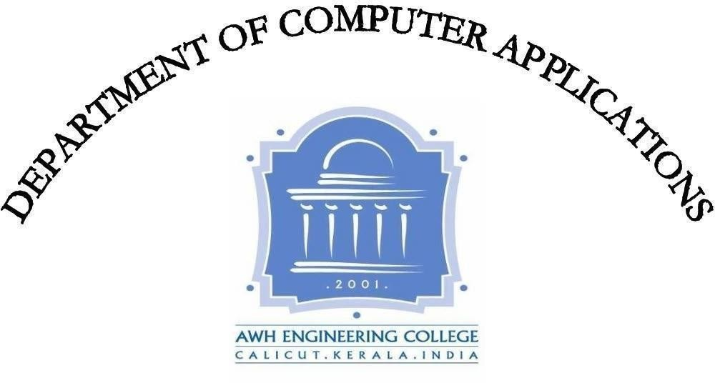

**AWH ENGINEERING COLLEGE** KOZHIKODE **CERTIFICATE**

*This is to certify that this thesis entitled “****NSS WEB PORTAL****” submitted herewith is an authentic record of the thesis work done by* ***MUHAMMED HILAL M (AWH21MCA-2021)*** *under our guidance in partial fulfillment of the requirements for the award of* ***Master of Computer Applications*** *from APJ ABDUL KALAM TECHNOLOGICAL UNIVERSITY during the academic year 2023.*

#### Mrs. Sruti Sudevan Mrs. Sruti Sudevan

Assistant Professor Assistant Professor

Head of the Department Project Guide

**External Examiner Internal Examiner**

## ACKNOWLEDGEMENT

I express my sincere gratitude to our beloved principal **Dr.Sabeena M V** for providing me an opportunity with the required facilities for doing this project. I express my heartily thanks to **Mrs. Sruti Sudevan**, Head of the department of MCA and Assistant professor for her guidance. I am thankfull to all other staff of the MCA department for their encouragement, timely guidance, valuable suggestions and inspiring ideas given throughout this mini project. I am grateful to my friends for the way they have cooperated, expected me to achieve success and have always stirred my ambition to do the best. Above all , I am grateful to the almighty, who has showered His blessings on me throughout my life and throughout the project.

**MUHAMMED HILAL M**

## ABSTRACT

The NSS Web Portal is a government-developed digital platform designed to streamline the management and coordination of National Service Scheme (NSS) activities at the state level. Its key features and modules include student registration, activity reporting, program management, attendance tracking, and volunteer management. The portal provides a range of tools to facilitate data analysis, report generation, and feedback collection, enabling authorities to effectively monitor and evaluate the progress of NSS activities within the state. This feature enhances decision-making and allows for informed interventions to improve the effectiveness of the NSS. Furthermore, the NSS Web Portal is scalable and customizable, allowing authorities to adapt it to their specific needs and requirements. This flexibility ensures that the portal can be tailored to accommodate different state-level processes and procedures related to NSS management. The NSS Web Portal serves as a powerful tool that simplifies the process of NSS management. By providing a centralized platform for various activities, it promotes efficient coordination and administration of NSS initiatives. Additionally, the portal encourages and nurtures the spirit of community service among the youth of the nation, as they actively participate in NSS programs and contribute to the betterment of society

|  |  |  |
| --- | --- | --- |
|  | **CONTENT** |  |
|  | **Page No** |
| 1.INTRODUCTION |  | 1 |
| 2.SYSTEM ANALYSIS |  | 3 |
| 2.1 Existing System |  | 4 |
| 2.2 Proposed System |  | 4 |
| 2.3 Module Description |  | 5 |
| 2.4 Sprint |  | 7 |
| 2.5 User Stories |  | 11 |
| 3.FEASIBILITY STUDY |  | 12 |
| 3.1 Economical Feasibility |  | 13 |
| 3.2 Technical Feasibility |  | 13 |
| 3.3 Operational Feasibility |  | 13 |
| 3.4 Behavioral Feasibility |  | 14 |
| 3.5 Software Feasibility |  | 14 |
| 3.6 Hardware Feasibility |  | 14 |

1. SOFTWARE ENGINEERING PARADIGM 15
   1. Agile Model 16
   2. Scrum 16
2. SYSTEM REQUIREMENT SPECIFICATIONS 19
   1. Software Requirements 20
   2. Hardware Requirements 20
3. SYSTEM DESIGN 21
   1. Database Design 22
   2. Collections 22
   3. UML Design 24
   4. Use Case Diagram 25
   5. Scenario 27
   6. Sequential Diagram 29
4. SYSTEM DEVELOPMENT 35
   1. Coding 36
5. SYSTEM TESTING AND IMPLEMENTATION 38
   1. Types of Testing 39
6. SYSTEM MAINTENANCE 41
7. FUTURE ENHANCEMENT 43
8. CONCLUSION 45
9. APPENDIX 47
10. BIBLIOGRAPHY 79

# INTRODUCTION

## INTRODUCTION

The NSS (National Service Scheme) Web Portal is a dedicated platform designed to facilitate the management and coordination of various NSS activities at the state level. This portal is an initiative taken by the government to digitize the entire process of NSS, making it more accessible and efficient for the users.

The Portal is equipped with various features and modules, such as student registration, activity reporting, program management, attendance tracking, and volunteer management. It also provides tools for data analysis, report generation, and feedback collection, making it easier for authorities to monitor and evaluate the progress of NSS activities in the state.

NSS Web Portal serves as a comprehensive and user-friendly platform that digitizes and streamlines the management of NSS activities. By providing a range of features and modules, it promotes efficient coordination, data-driven decision-making, and active engagement among NSS stakeholders. Ultimately, this initiative aims to nurture the spirit of community service and empower the youth of the nation to contribute meaningfully to society.

Moreover, the NSS Web Portal is designed to be scalable and customizable, allowing authorities to tailor it to their specific needs and requirements. It is a powerful tool that simplifies the process of NSS management and helps promote the spirit of community service among the youth of the nation.

# SYSTEM ANALYSIS

## SYSTEM ANALYSIS

System analysis is the process of gathering and interpreting facts, problems and using the information to recommend improvements of the system.

#### Existing System

The existing system of the NSS (National Service Scheme) Web Portal is a digital platform that facilitates the management and coordination of various NSS activities at the university level. The portal is designed to provide a interface for colleges to register for NSS programs, report their activities and also still relies on manual processes and paper-based documentation in some cases, such as the submission of physical forms and documents.

#### Limitations Of Existing System

* + - Lack of customization
    - Dependence on manual processes
    - Limited accessibility

#### Proposed System

A proposed system for the NSS (National Service Scheme) Web Portal and software would be designed to address the limitations of the existing system and provide a more accessible, efficient, and effective platform for managing NSS activities in state level.

#### Advantages Of Proposed System

* + - Improved accessibility
    - Increased efficiency
    - Customization
    - Integration
    - Reliable infrastructure

#### Module Description

This project has six modules.

##### Admin(State coordinator)

* + Login.
  + Manage Profile
  + Manage Events
  + Manage News
  + Authentication of University Coordinators
  + Manage University Coordinators
  + Manage Fund Details
  + Enrolment List View
  + Reports View
  + Feedback View
  + Suggestion View
  + Messaging

##### University coordinator

* + Registration
  + Login.
  + Manage Profile
  + Authentication of Program Officer
  + Manage Program Officer
  + Manage Fund Details
  + Enrolment List View
  + Reports View
  + Feedback View
  + Messaging.

##### Program Officer

* + Registration
  + Login.
  + Manage Profile
  + Authentication of Volunteers
  + Manage Volunteers
  + Manage Secretary
  + Manage Fund Details
  + Manage Project Reports
  + Manage Camp Reports
  + Enrolment List View
  + Reports View
  + Attendance View
  + Manage Work Dairy
  + Feedback View
  + Messaging

## Secretary

* + Login
  + Manage Project Reports
  + Manage Camp Reports

##### Volunteers

* + Registration
  + Login
  + Manage Profile
  + Manage Work Dairy
  + Manage Extra Reports

##### Public

* + Add Feedback
  + Add Suggestion
  1. **Sprint**

Sprint 1

|  |  |  |  |  |  |  |
| --- | --- | --- | --- | --- | --- | --- |
| Module | Task | Pending task of any | Hours for completio n | Expected date of completion | Actual date of completion | Reason for deviati on |
| Admin | Login. | - | 4 hrs | 01/02/2023 | 01/02/2023 | - |
| Manage Profile | - | 4 hrs | 02/02/2023 | 02/02/2023 | - |
| Manage Events | - | 6 hrs | 03/02/2023 | 03/02/2023 | - |
| Manage News | - | 6 hrs | 06/02/2023 | 06/02/2023 | - |
| Authentication of  University Coordinators | - | 6 hrs | 07/02/2023 | 07/02/2023 | - |
| Manage University  Coordinators | - | 6 hrs | 08/02/2023 | 08/02/2023 | - |
| Manage Fund Details | - | 6 hrs | 09/02/2023 | 09/02/2023 | - |
| Enrolment List View | - | 6 hrs | 10/02/2023 | 10/02/2023 | - |
| Reports View | - | 6 hrs | 16/02/2023 | 16/02/2023 | - |
| Feedback View | - | 4 hrs | 17/02/2023 | 17/02/2023 | - |

|  |  |  |  |  |  |  |
| --- | --- | --- | --- | --- | --- | --- |
|  | Suggestion View | - | 6 hrs | 20/02/2023 | 20/02/2023 | - |
| Messaging | - | 6 hrs | 21/02/2023 | 21/02/2023 | - |
| Secretary | Manage Project Reports | - | 12 hrs | 23/02/2023 | 23/02/2023 | - |
| Manage Camp Reports | - | 12 hrs | 28/02/2023 | 28/02/2023 | - |

Sprint 2

|  |  |  |  |  |  |  |
| --- | --- | --- | --- | --- | --- | --- |
| Module | Task | Pending task of any | Hours for completio n | Expected date of completion | Actual date of completion | Reason for deviati on |
| University Coordinat or | Registration | - | 6 hrs | 06/03/2023 | 06/03/2023 | - |
| Manage Profile | - | 4 hrs | 07/03/2023 | 07/03/2023 | - |
| Authentication of Program Officer | - | 6 hrs | 08/03/2023 | 08/03/2023 | - |
| Manage Program Officer | **-** | 6 hrs | 10/03/2023 | 10/03/2023 | - |
| Manage Fund Details | **-** | 6 hrs | 13/03/2023 | 13/03/2023 | - |
| Enrolment List View |  | 6 hrs | 14/03/2023 | 14/03/2023 | - |
| Reports View |  | 6 hrs | 15/03/2023 | 15/03/2023 | - |

|  |  |  |  |  |  |  |
| --- | --- | --- | --- | --- | --- | --- |
|  | Feedback View |  | 4 hrs | 17/03/2023 | 17/03/2023 | - |
| Volunteer | Registration | - | 6 hrs | 20/03/2023 | 20/03/2023 | - |
|  | Manage Profile | - | 4 hrs | 21/03/2023 | 21/03/2023 | - |
| Manage Work Dairy | - | 10 hrs | 23/03/2023 | 23/03/2023 | - |
| Manage Extra Reports | - | 10 hrs | 29/03/2023 | 29/03/2023 | - |
| Public | Add Feedback | - | 8hrs | 30/03/2023 | 30/04/2023 | - |
| Add Suggestion | - | 8hrs | 31/03/2023 | 31/04/2023 | - |

.

Sprint 3

|  |  |  |  |  |  |  |
| --- | --- | --- | --- | --- | --- | --- |
| Module | Task | Pending task of any | Hours for completio n | Expected date of completion | Actual date of completion | Reason for deviati on |
| Program Officer | Registration | - | 6 hrs | 03/04/2023 | 03/04/2023 | - |
| Manage Profile | - | 4 hrs | 04/04/2023 | 04/04/2023 | - |
| Authentication of Volunteers | - | 6 hrs | 05/04/2023 | 05/04/2023 | - |

|  |  |  |  |  |  |  |
| --- | --- | --- | --- | --- | --- | --- |
|  | Manage Volunteers | - | 6 hrs | 07/04/2023 | 07/04/2023 | - |
| Manage Secretary | - | 6 hrs | 10/04/2023 | 10/04/2023 | - |
| Manage Fund Details | - | 6 hrs | 11/04/2023 | 11/04/2023 | - |
| Manage Project Reports | - | 12 hrs | 17/04/2023 | 17/04/2023 | - |
| Manage Camp Reports | - | 12 hrs | 19/04/2023 | 19/04/2023 | - |
| Enrolment List View | - | 6 hrs | 24/04/2023 | 24/04/2023 | - |
| Reports View | - | 6 hrs | 25/04/2023 | 25/04/2023 | - |
| Attendance View | - | 6 hrs | 26/04/2023 | 26/04/2023 | - |
| Manage Work Dairy | - | 10 hrs | 28/04/2023 | 28/04/2023 | - |
| Feedback View | - | 4 hrs | 29/04/2023 | 29/04/2023 | - |
| Messaging | - | 6 hrs | 30/04/2023 | 30/04/2023 | - |

#### User Stories

This portal have 5 modules Admin, University Coordinator ,Program Officer, Secretary, Volunteer and Public.

The Admin should be able to manage profile, manage events and news, authentication of university coordinators, manage university coordinators, Manage Fund Details, enrolment list view, reports view, feedback view, suggestion view, messaging

The University Coordinator should be able to manage profile

,authentication of program officer, manage program officer, Manage Fund Details, enrolment list view, reports view, feedback view, suggestion view, messaging

The Program Officer should be able to manage profile, authentication of volunteers, manage volunteers, manage secretary, Manage Fund Details, manage work dairy, manage project, manage camps, attendance view, enrolment list view, reports view, feedback view, suggestion view, messaging

The Secretary should be able to manage project and manage program camps. the volunteer should be able to manage work dairy and manage extra reports and the public should be able to add feedback and add suggestion.

# FEASIBILITY STUDY

## FEASIBILITY STUDY

An analysis of the ability to complete a project successfully, taking into account legal, economic, technological, scheduling, and other factors is considered a feasibility study. Rather than just diving into a project and hoping for the best, feasibility study allows project managers to investigate the possible negative and positive outcomes of a project before investing too much money and time.

#### Economic Feasibility

The economic analysis is done to determine the benefits and savings that are expected from the candidate system and compare them with costs. Thus, coming to a conclusion on whether the system is economically feasible or not. This system is cost effective as well as time effective, thereby making it economically feasible. This study presents tangible and intangible benefits from the project by comparing the developments and operational costs. The technique of cost benefit analysis is often used as a basis for assessing economic feasibility.

#### Technical Feasibility

The technical requirements for the system are economic and it does not use additional software. This application is developed using MERN Stack, whose development kit are easily available and free of cost, thus making our system technically feasible.

#### Operational Feasibility

This analysis involves how it will work when it is installed and the assessment of political and managerial environment in which it is implemented. The new proposed system is very much useful to the users and there for it will accept broad audience.

#### Behavioural Feasibility

This analysis involves how it will work when it is installed and the assessment of the political and managerial environment in which it is implemented. People are inherently resistant to change and computers have been known to facilitate change. The new proposed system is very much useful to the users and therefore it will accept a broad audience.

#### Software Feasibility

Even though this application is developed in a very high software environment, it is also supported by many other environments with minimal changes. The system is fully feasible to be executed on any kind of operating systems and browsers.

#### Hardware Feasibility

Software can be developed with the existing resources. But the existing resources may or may not be used to produce hardware. If no hardware is newly bought for a project, then software is said to achieve hardware feasibility. The system is hardware-wise feasible because it needs absolutely no new hardware.

# SOFTWARE ENGINEERING PARADIGM

### SOFTWARE ENGINEERING PARADIGM

The software engineering paradigm which is also referred to as a software process model or Software Development Life Cycle (SDLC) model is the development strategy that encompasses the process, methods and tools. SDLC describes the period of time that starts with the software system being conceptualized.

#### Agile Model

Agile SDLC model is a combination of iterative and incremental process models with focus on process adaptability and customer satisfaction by rapid delivery of working software product. Agile Methods break the product into small incremental builds. These builds are provided in iterations. Each iteration typically lasts from about one to three weeks. At the end of the iteration, a working product is displayed to the customer and important stakeholders.

In Agile, the tasks are divided to time boxes (small time frames) to deliver specific features for a release. Iterative approach is taken and working software build is delivered after each iteration. Each build is incremental in terms of features; the final build holds all the features required by the customer.

#### scrum

Scrum is an agile framework for managing knowledge work, with an emphasis on software development. It is designed for teams of three to nine members, who break their work into actions that can be completed within time boxed iterations, called "sprints", no longer than one month and most commonly two weeks, then track progress and re-plan in 15-minute stand-up meetings, called daily scrums.

Scrum is an iterative and incremental framework for managing product development. It defines "a flexible, holistic product development strategy where a development team works as a unit to reach a common goal", challenges assumptions of the "traditional, sequential approach to

product development, and enables teams to selforganize by encouraging physical co-location or close online collaboration of all team members, as well as daily face-to-face communication among all team members and disciplines involved.

Scrum is a framework that helps teams work together. Much like a rugby team (where it gets its name) training for the big game, scrum encourages teams to learn through experiences, self-organize while working on a problem, and reflect on their wins and losses to continuously improve.

While the scrum is talking about is most frequently used by software development teams, its principles and lessons can be applied to all kinds of teamwork. This is one of the reasons scrum is so popular. Often thought of as an agile project management framework, scrum describes a set of meetings, tools, and roles that work in concert to help teams structure and manage their work.

Scrum is the most common agile framework, and the one most people start with. Agile practices on the other hand, are techniques applied during phases of the software development lifecycle. Planning poker for example, is a collaborative estimation practice designed to encourage team members to share their understanding of what done means. The process is quite fun, and has proven to help foster teamwork and better estimates. Continuous integration (also known as ci) is a common agile engineering practice where code changes are integrated into the main branch frequently. An automated build verifies changes, leading to a reduction in integration debt and a continually shippable main branch. These practices, like all agile practices, carry the agile label, because they are consistent with the principles in the agile manifesto.

In the project management, scrum, sometimes written scrum or scrum, is a framework for developing, delivering, and sustaining products in a complex environment, with an initial emphasis on software development, although it has been used in other fields including research, sales, marketing and advanced technologies. It is designed for teams of ten or fewer members, who break their work into goals that can be completed within time-boxed iterations, called sprints, no longer than one month and most commonly two weeks. The scrum team assess progress in time-boxed daily meetings of 15

minutes or less, called daily scrums (a form of stand-up meeting). At the end of the sprint, the team holds two further meetings: the sprint review which demonstrates the work done to stakeholders to elicit feedback, and sprint retrospective which enables the team to reflect and improve.

A key principle of scrum is the dual recognition that customers will change their minds about what they want or need and that there will be unpredictable challenges-for which a predictive or planned approach is not suited. As such, scrum adopts an evidencebased empirical approach accepting that the problem cannot be fully understood or defined up front, and instead focusing on how to maximize the team's ability to deliver quickly, to respond to emerging requirements, and to adapt to evolving technologies and changes in market conditions. Many of the terms used in scrum (e.g., scrum master) are typically written with leading capitals (e.g., scrum master) or as conjoint words written in camel case (e.g., scrum master). To maintain an encyclopaedic tone, however, this article uses normal sentence case for these terms-unless they are recognized marks. This is occasionally seen written in all -capitals, as scrum. The word is not an acronym, so this is not correct; however, it likely arose due to an early paper by ken schwaber which capitalized scrum in its title. While the trademark on the term scrum itself has been allowed to lapse, so that it is deemed as owned by the wider community rather than an individual, the leading capital is retained-except when used with other words.

# SYSTEM REQUIREMENT SPECIFICATION

## SYSTEM REQUIREMENT SPECIFICATION

#### Software Requirements

One of the most difficult tasks is selecting software, once the system requirement is find out then we have to determine whether a particular software package fits for those system requirements. This section summarizes the application requirement.

|  |  |  |
| --- | --- | --- |
| * Operating System | : | Windows 7 or above |
| * Front End | : | Html, CSS, JavaScript |
| * Back End | : | Node JS, Express JS |
| * IDE | : | Visual Studio |
| * Database | : | Mongo DB |

#### Hardware Requirements

The selection of hardware is very important in the existence and proper working of any of the software. When selecting hardware, the size and capacity requirements are also important. The hardware must suit all application developments**.**

|  |  |  |
| --- | --- | --- |
| * Processor | : | Intel core i3 or above |
| * RAM | : | 8GB |
| * HDD | : | 1 TB |

# SYSTEM DESIGN

## SYSTEM DESIGN

System design is the first in the development phase for many engineered products or systems. It may define the process of applying various techniques and principles for the purpose of defining a device, a process or system in sufficient detail to permit its physical realisation.

#### MongoDB

Database design is the process of producing a detailed data model of a database. This logical data model contains all the needed logical and physical design choices and physical storage parameters needed to generate a design in a data definition language, which can then be used to create a database. The term database design can be used to describe many different parts of the design of an overall database system.

Non-relational model databases, also known as NoSQL databases, are a type of database management system that diverge from the traditional relational model. Instead of relying on tables with predefined schemas and fixed relationships, NoSQL databases use flexible and dynamic data models, such as document-based, key-value, graph, or column-family.

#### Collections

In MongoDB, a collection is a grouping of MongoDB documents. It is the equivalent of a table in relational databases. Collections exist within databases and can store multiple documents in a structured format. Each document within a collection can have a unique structure, meaning they don't have to follow a rigid schema like in traditional relational databases.

#### Project Collection

* + - admin_account
    - admin_index_event
    - admin_index_news
    - admin_message
    - feedback
    - login
    - old_register
    - po_account
    - po_camp_creation
    - po_camp_report
    - po_message
    - po_project_creation
    - po_project_report
    - po_register
    - po_workdairy
    - secretary_camp
    - secretary_project
    - suggestion
    - unicod_account
    - unicod_message
    - unicod_register
    - volunteer_extra
    - volunteer_register
    - volunteer_workdairy

#### UML Design

The Unified Modelling Language (UML) is indeed a standardized language used for specifying, visualizing, constructing, and documenting software systems, as well as for business modelling and other non-software systems. It encompasses a collection of best engineering practices that have been proven successful in modelling large and complex systems. UML provides a set of graphical notations that allow software developers and other stakeholders to express and communicate the design of software projects effectively. By using UML, project teams can visualize and explore potential designs, communicate design decisions, and validate the architectural design of the software system. UML diagrams serve as a means to represent various aspects of the system being developed. These diagrams can be used to depict the structure of the system, its behaviour , interactions between components, and the overall flow of activities. The graphical nature of UML diagrams makes them intuitive and easier to understand for both technical and non-technical stakeholders involved in the software development process. UML provides a standardized and widely accepted notation, which promotes consistency and clarity in design documentation. This allows for better collaboration among team members and facilitates the understanding and maintenance of software systems over time. The use of UML in software development can enhance communication, facilitate design exploration, and provide a solid foundation for developing and documenting complex software systems

#### Use Case Diagram

**1)**

#### NSS Web Portal

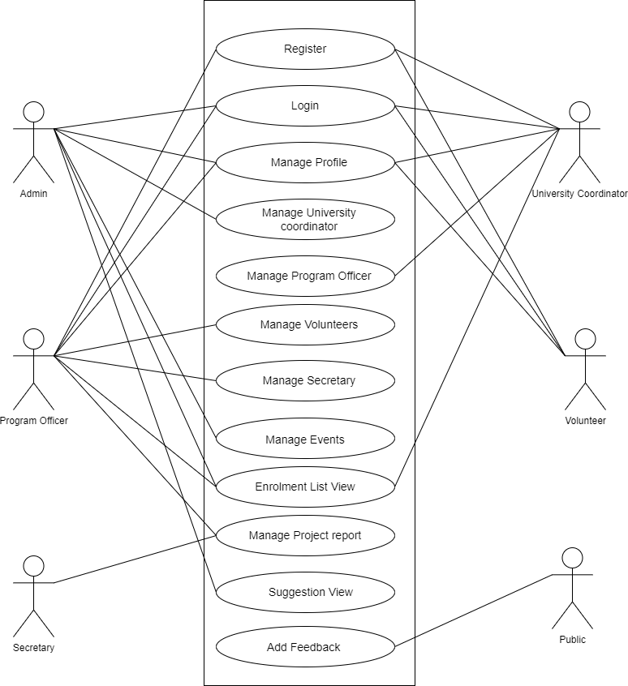

**2)**

#### NSS Web Portal

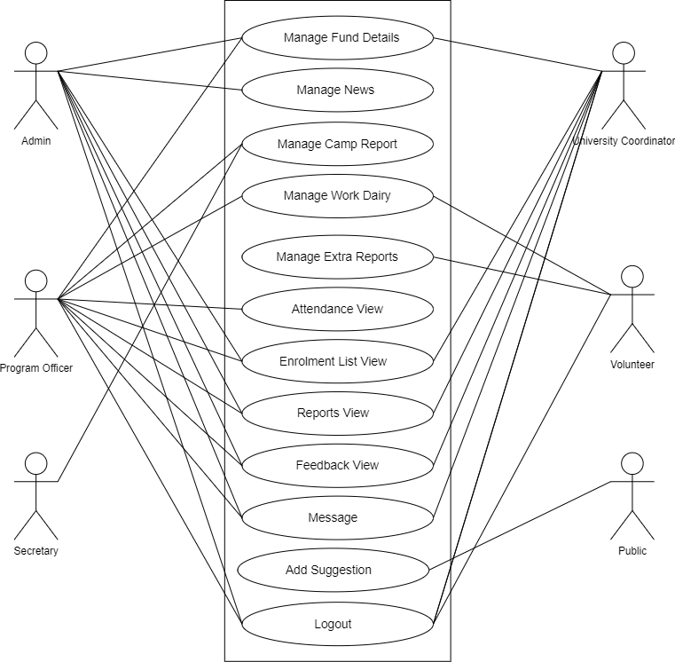

#### Scenario

##### Admin(State coordinator)

* Login.
* Manage Profile
* Manage Events
* Manage News
* Authentication of University Coordinators
* Manage University Coordinators
* Manage Fund Details
* Enrolment List View
* Reports View
* Feedback View
* Suggestion View
* Messaging

##### University coordinator

* Registration
* Login.
* Manage Profile
* Authentication of Program Officer
* Manage Program Officer
* Manage Fund Details
* Enrolment List View
* Reports View
* Feedback View
* Messaging

##### Program Officer

* Registration
* Login.
* Manage Profile
* Authentication of Volunteers
* Manage Volunteers
* Manage Secretary
* Manage Fund Details
* Manage Project Reports
* Manage Camp Reports
* Enrolment List View
* Reports View
* Attendance View
* Manage Work Dairy
* Feedback View
* Messaging

##### Secretary

* Login
* Manage Project Reports
* Manage Camp Reports
* Messaging

##### Volunteers

* Registration
* Login
* Manage Profile
* Manage Work Dairy
* Manage Extra Reports

##### Public

* Add Feedback
* Add Suggestion

#### Sequential Diagram

**Admin (State coordinator) 1)**

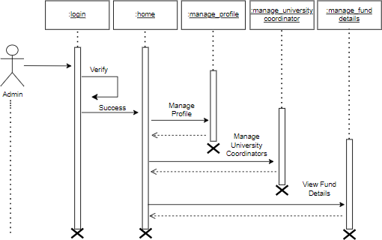

#### 2)

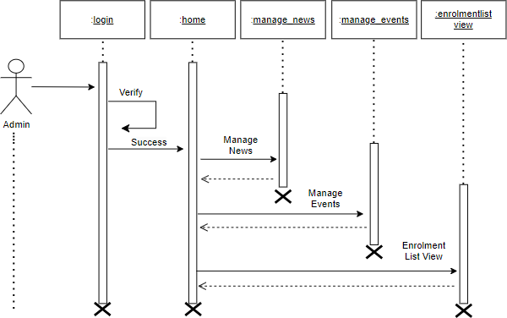

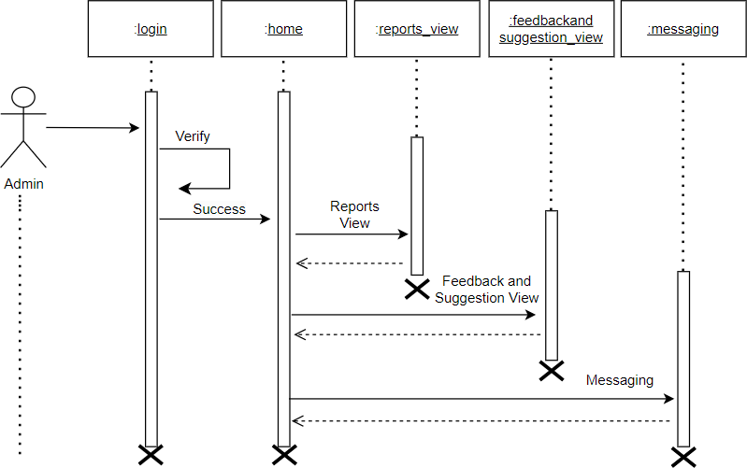

**University coordinator**

#### 1)

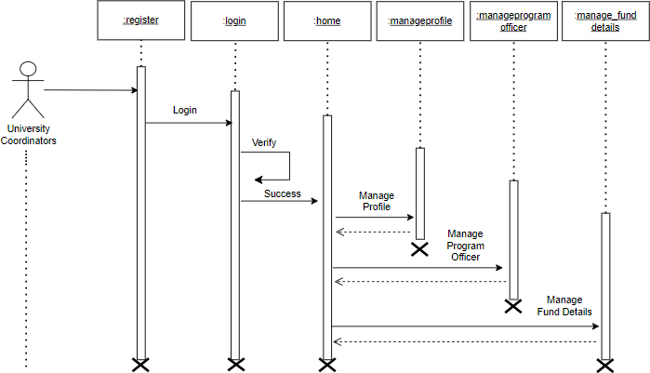

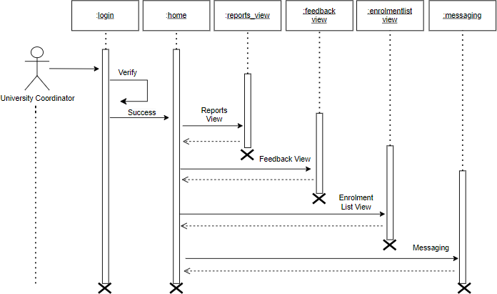

**Program Officer 1)**

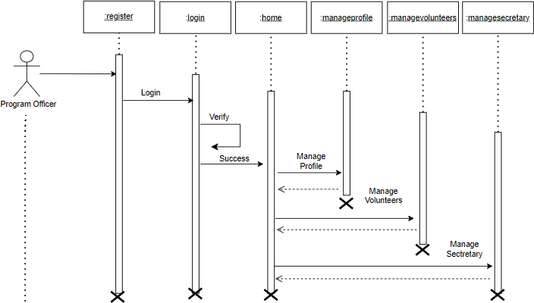

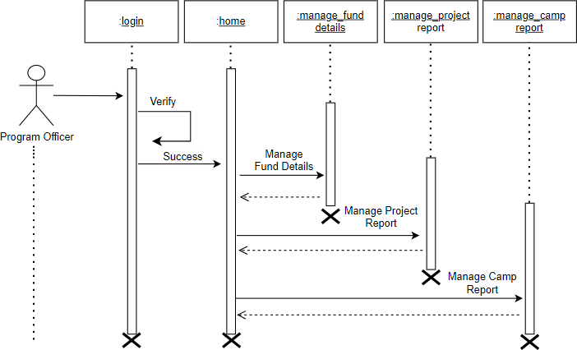

#### 3)

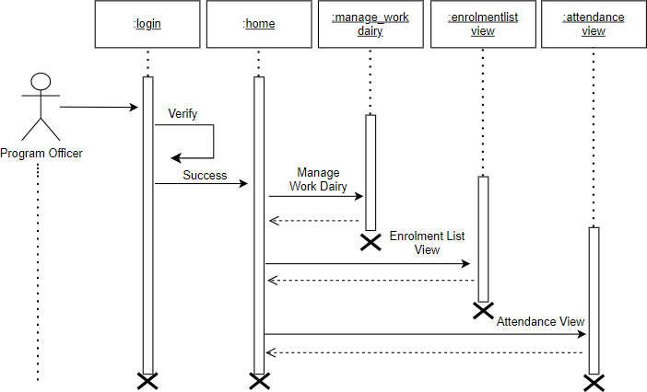

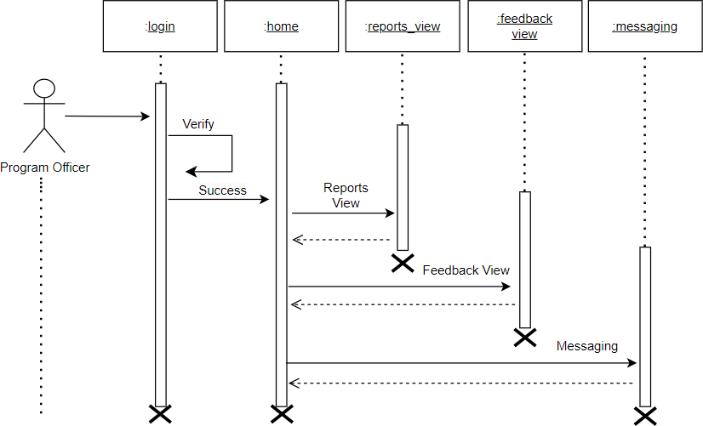

**Secretary**

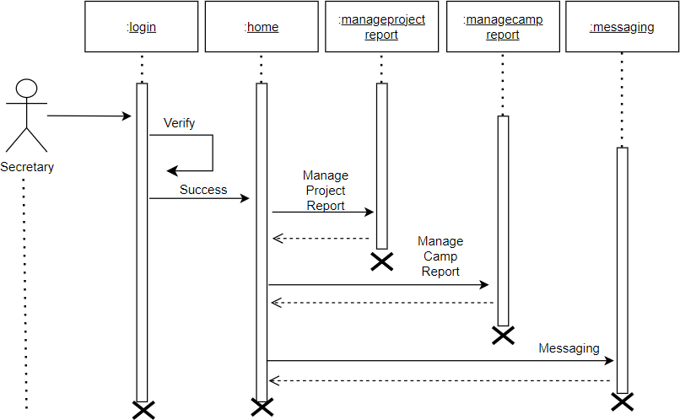

#### Volunteers

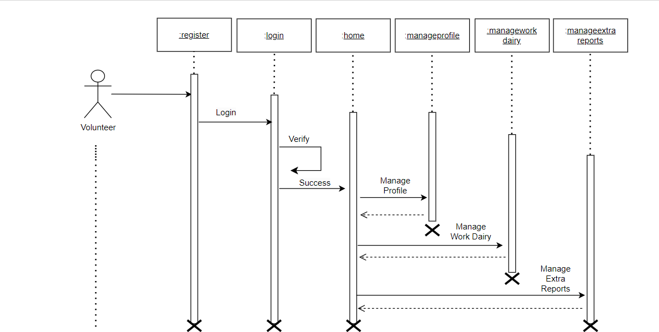

**Public**

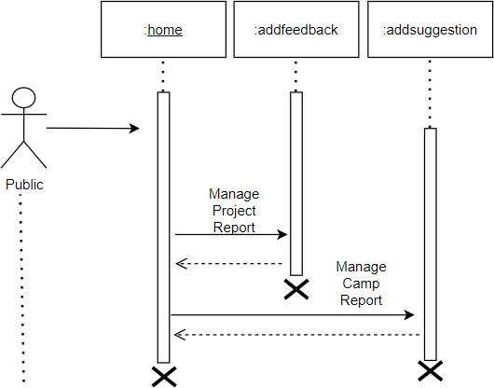

# SYSTEM DEVELOPMENT

## SYSTEM DEVELOPMENT

System development is a series of operations to manipulate data to produce output from a computer system. The principal activities performed during the development phase can be divided into two major related sequences.

* External system development
* Internal system development

The major external system activities are:

* Implementation
* Planning
* Equipment acquisition
* Installation

#### 7.1 Coding

The purpose of code is to facilitate the identification and retrieval of items of information. A code is an ordered collection of symbols designed to provide unique identification of an entity or an attribute. Code also shows interrelationship among different items. Codes are used to identify, access, sort, matching records. The code ensures that only one value of code with a single meaning is applied to give an entity or attribute as described in various ways.

#### Node JS

Node js is an open-source, cross-platform JavaScript runtime environment that enables developers to build scalable and high-performance applications. It is built on top of the V8 JavaScript engine used by Google Chrome and provides an event-driven, non-blocking I/O model that makes it well-suited for real-time web applications. Node.js enables developers to write server-side applications using JavaScript, which is a popular and widely-used programming language on the web. It has a vast ecosystem of third-party packages and libraries that can be easily installed using the Node Package Manager (NPM). Node js applications

can be run on various platforms such as Windows, Mac, and Linux.

#### Express JS

Express.js is a minimal and flexible Node.js web application framework that provides a set of robust features for building web and mobile applications. It is one of the most popular and widely-used frameworks for Node.js, and is known for its simplicity and ease of use. Express.js provides a set of features for developing serverside web applications, including routing, middleware support, template engines, and much more. It also provides an easy-to-use API for interacting with databases such as MongoDB and MySQL, and supports a variety of templating engines, such as Pug, Handlebars, and EJS..

#### Mongo DB

MongoDB is a popular document-oriented NoSQL database system that allows developers to store and manage large amounts of data in a flexible and scalable way. It is an open-source database that uses JSON-like documents with optional schemas, which makes it easy to work with and suitable for a variety of use cases. One of the key benefits of MongoDB is its ability to scale horizontally. This means that developers can add new servers to their database cluster as the amount of data or traffic increases, which allows the database to handle more requests and ensures that it can continue to perform well even as the application grows.

# SYSTEM TESTING AND IMPLEMENTATION

## SYSTEM TESTING AND IMPLEMENTATION

Testing is vital to the success of the system. It makes a logical assumption that if all the parts of the system are correct, the goal will be successfully achieved in this projec**t**. It is the stage of implementation, which ensures that the system works accurately and effectively before the live operation commences. It is a confirmation that all are correct and an opportunity to show users that the system must be tested and show that the system will operate successfully and produce expected results under expected conditions. Software testing is a crucial element of software quality assurance and represents the unlimited review of specification, design and coding. Testing represents an interesting anomaly for the software. During the earlier definition and development phase, it was attempted to build the software from an abstract concept to implement.

Testing is a set of activities that can be planned in advance and conducted**.** Systematically, this is aimed at ensuring that the system works accurately and efficiently before live operations commences

#### Types Of Testing

Different types of testing are:

* + - Unit testing
    - Black Box Testing

#### Unit testing

Unit testing is usually conducted as part of a combined code and unit test phase of the software lifecycle, although it is not uncommon for coding and unit testing to be conducted as two distinct phases. All modules were tested individually as soon as they were completed and were checked for their correct functionality. Unit testing deals with testing a unit as a whole. This would test the interaction of many functions but confine the test within one unit. This testing is carried out during the programming stage itself. In this testing step each Module is found to be working satisfactorily as regard to the expected output from the module.

#### Black Box Testing

In black-box testing the structure of the program is not considered. Test cases are decided solely on the basis of the requirements or specifications of the program or module, and the internals of the module or the program are not considered for selection of test cases. In black-box testing, the tester only knows the inputs that can be given to the system and what output the system should give. This form of testing is also called functional or behavioural testing. The most obvious functional testing procedure is exhaustive testing. One criterion for generating test cases is to generate them randomly. There are no formal rules for designing test cases for functional testing.

# SYSTEM MAINTENANCE

## SYSTEM MAINTENANCE

Maintenance is making adaptation of the software for external changes (requirements changes or enhancements) and internal changes (fixing bugs). When changes are made during the maintenance phase all preceding steps of the model must be revisited.

There are three types of maintenance:

* + - Corrective (Fixing bugs/errors)
    - Adaptive (Updates due to environment changes)
    - Perfective (Enhancements, requirements changes)

Maintenance is an enigma of the system development. The definition of the software maintenance can be given describing four activities that are undertaken after the program is released for use.

The maintenance activity occurs since it is unreasonable to assume that software testing will uncover all in a large system. The second activity that contributes to the definition of maintenance occurs since rapid changes are encountered in every aspect of computing. The third activity involves recommendation for new capabilities, modification to the existing functions and general enhancements when the software is used. The fourth maintenance activity occurs when software is changed to improve future maintainability or reliability.

# FUTURE ENHANCEMENT

## FUTURE ENHANCEMENT

The NSS Web Portal is already a powerful platform that provides numerous features and modules for managing various NSS activities. However, there are several areas where the portal can be enhanced to further improve its functionality and usability. Some possible future enhancements could include. Developing a mobile app for the NSS Web Portal can make it more accessible to users who are always on the go. The app can provide a simplified version of the portal, with features such as student registration, activity reporting, and attendance tracking. The app can also send notifications and alerts to users regarding upcoming events and activities. Integrating the NSS Web Portal with popular social media platforms such as Facebook, Twitter, and Instagram can help promote the National Service Scheme and increase engagement with students.

This integration can allow users to share their experiences and achievements on social media, which can encourage others to participate in the program. Incorporating artificial intelligence (AI) technology into the NSS Web Portal can help automate various processes and improve the overall efficiency of the platform. AI can be used to analyse data, identify patterns, and make predictions, which can provide valuable insights to authorities and help them make informed decisions . The chat bot's capabilities to handle a broader range of tasks. Adding multilingual support to the NSS Web Portal can make it accessible to a wider audience, especially those who are more comfortable in their native language. This can help promote the National Service Scheme in different regions and communities and encourage more students to participate in NSS activities.

# CONCLUSION

## CONCLUSION

The National Service Scheme (NSS) Web Portal is a dedicated platform designed to facilitate the management and coordination of various NSS activities at the state level. It is an initiative taken by the government to digitize the entire process of NSS, making it more accessible and efficient for the users. The portal is equipped with various features and modules, such as student registration, activity reporting, program management, attendance tracking, and volunteer management, that simplify the process of NSS management and help promote the spirit of community service among the youth of the nation.

Moreover, the NSS Web Portal is scalable and customizable, allowing authorities to tailor it to their specific needs and requirements. It is a powerful tool that enhances transparency and accountability and provides valuable insights into the effectiveness of various initiatives.

Overall, the NSS Web Portal is an excellent initiative that leverages the power of technology to promote the culture of volunteerism and community service among the youth of the nation. It is a valuable tool that streamlines the operations of the National Service Scheme, enhances transparency and accountability, and provides valuable insights into the impact of various initiatives

# APPENDIX

## APPENDIX

#### Home Page

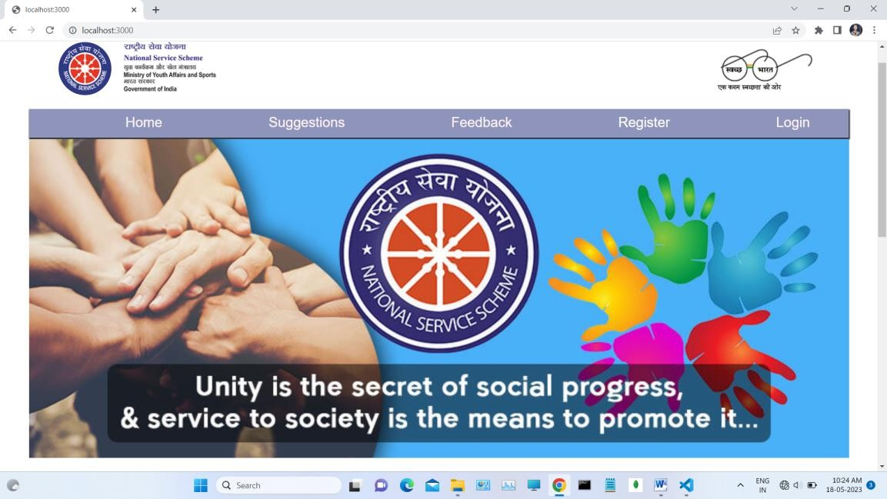

**Login**

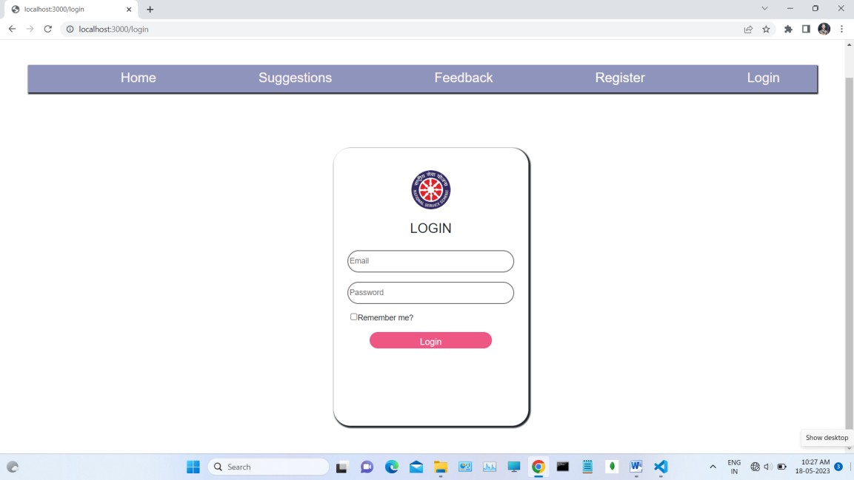

#### University Coordinator Registration Form

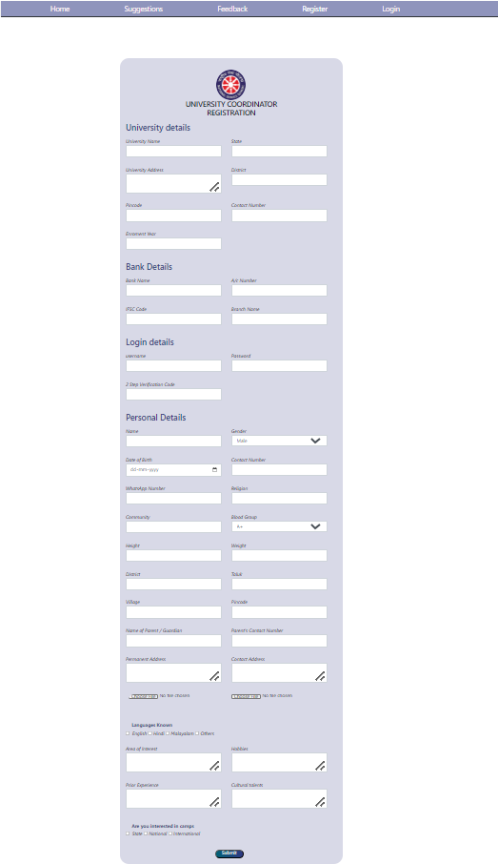



**Program Officer Registration Form**

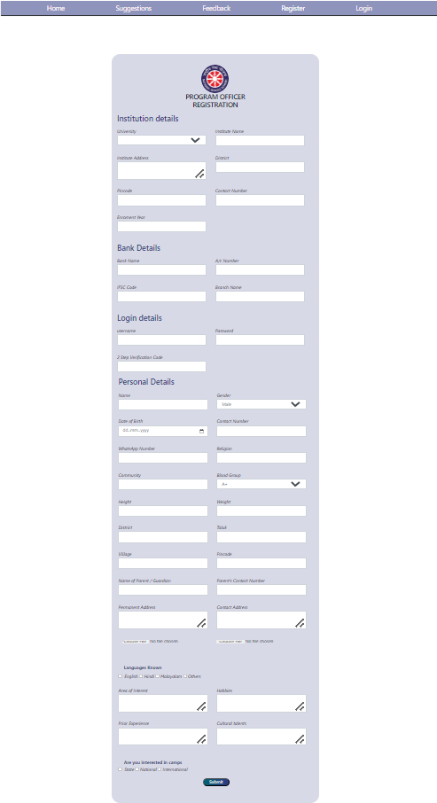



#### Volunteer Registration Form

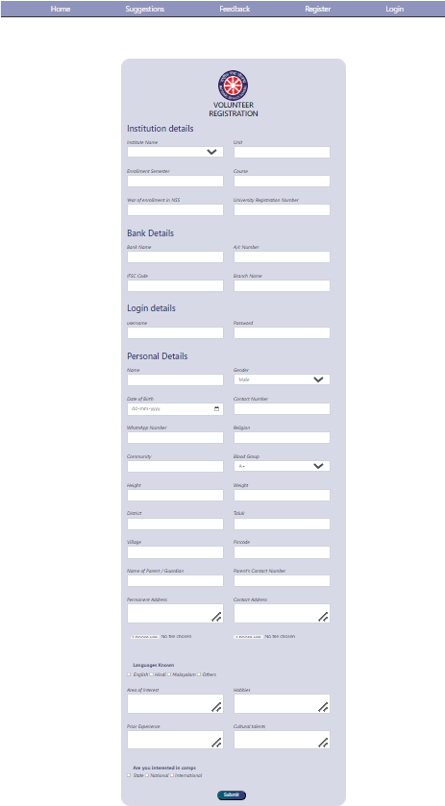



**Latest Events and News View**

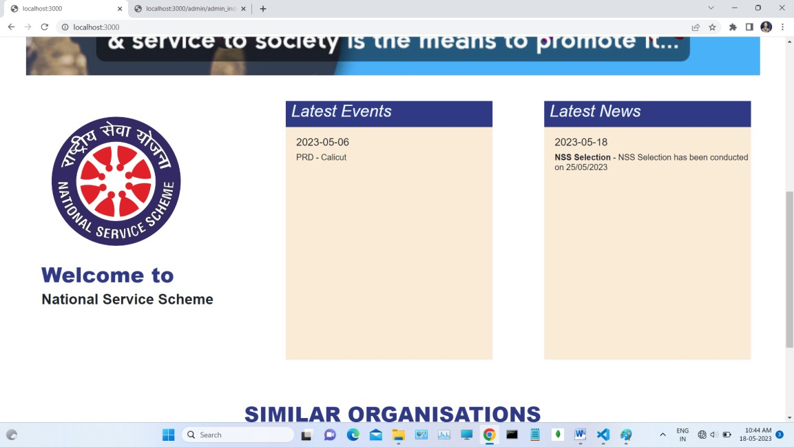

#### Add Suggestions

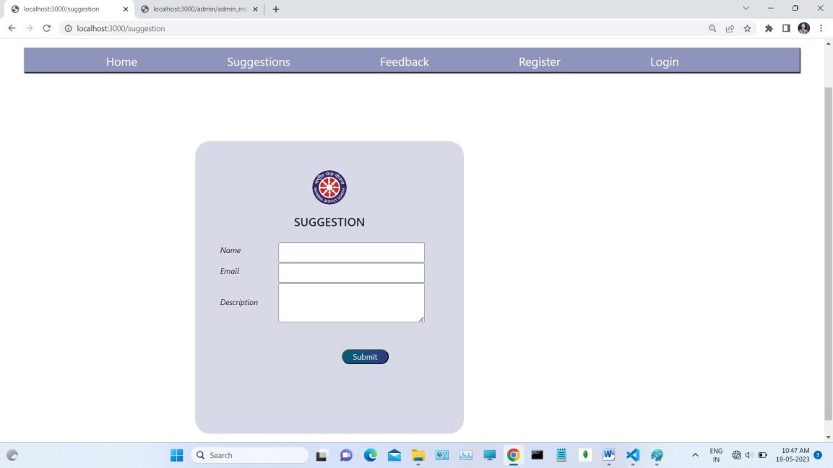

**Add Feedback**

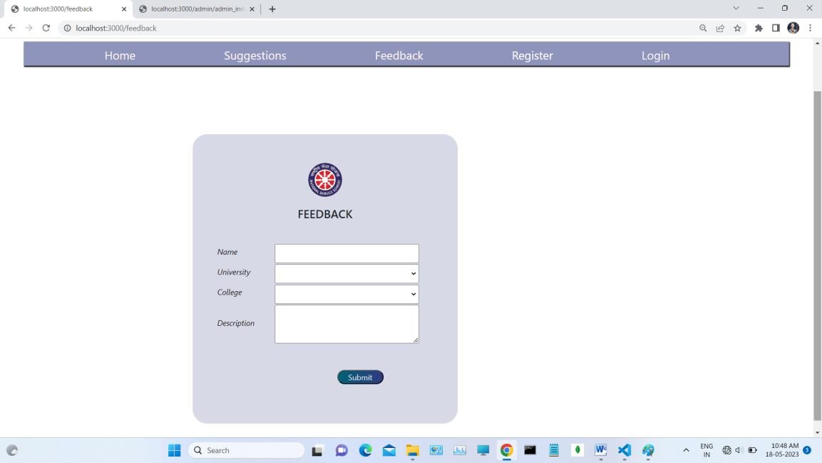

#### Authentication of University Coordinator

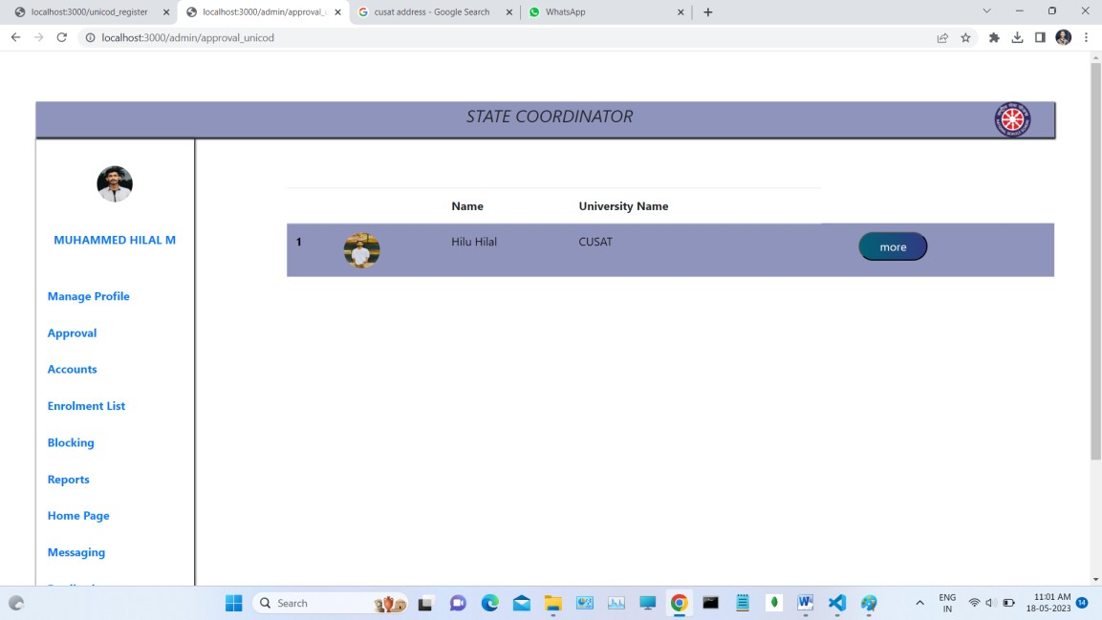

**Add Fund Details of University**

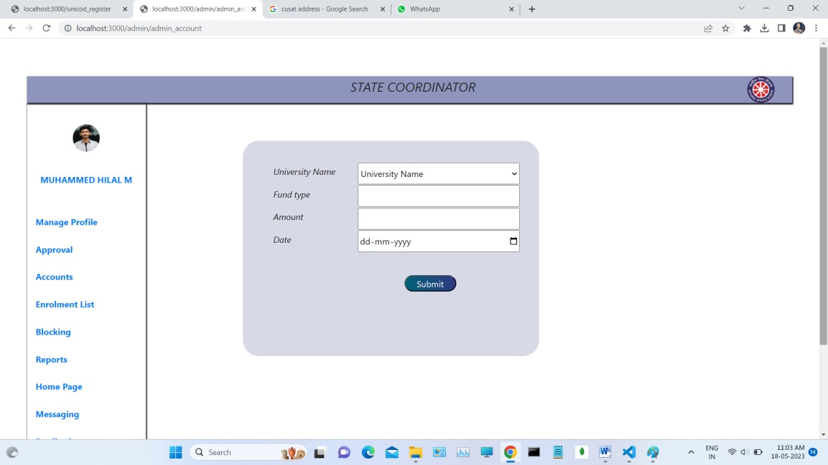

#### Fund Details View of University

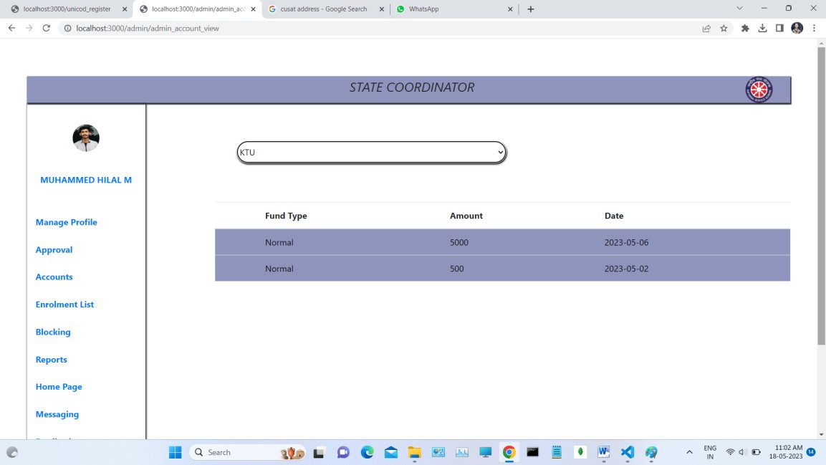

**Enrolment List of University Coordinators**

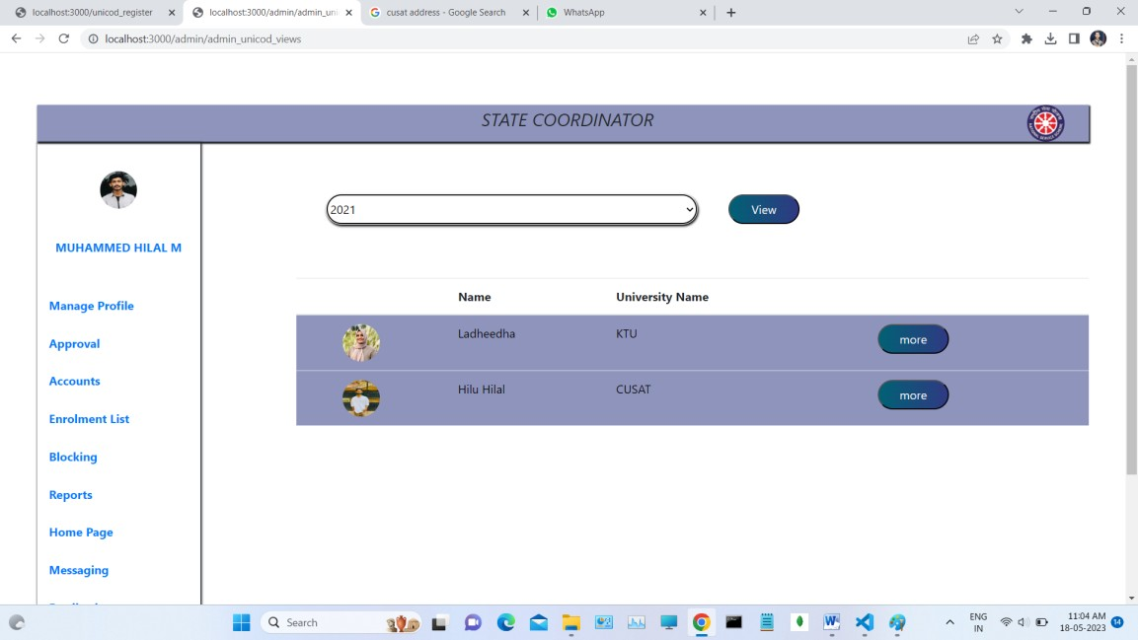

#### Enrolment List of Program Officer

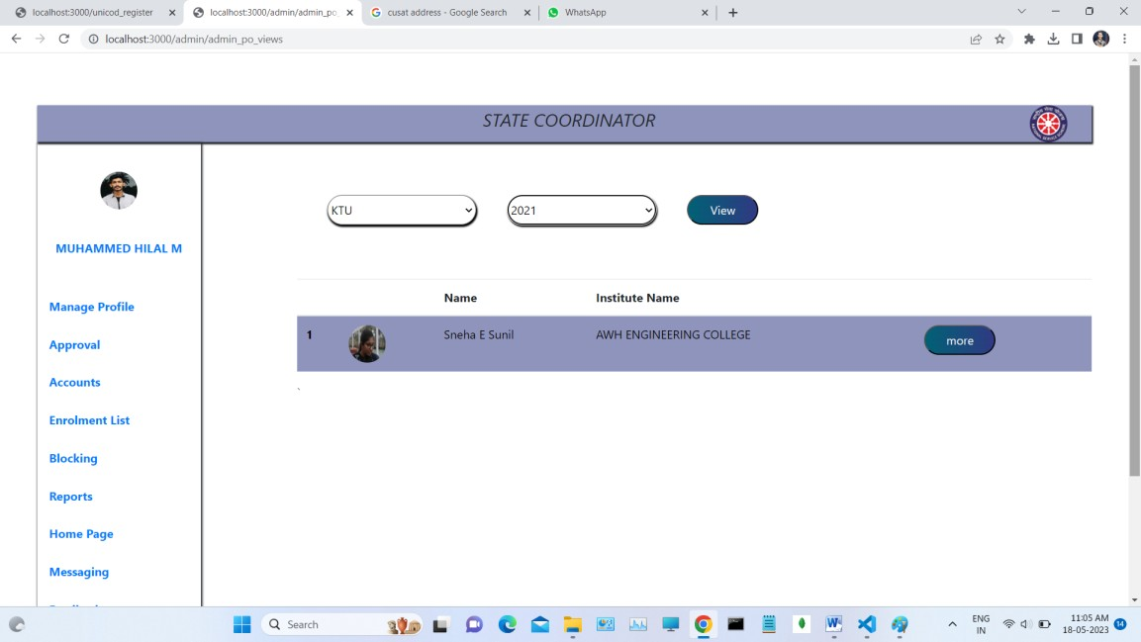

**Enrolment List of Volunteers**

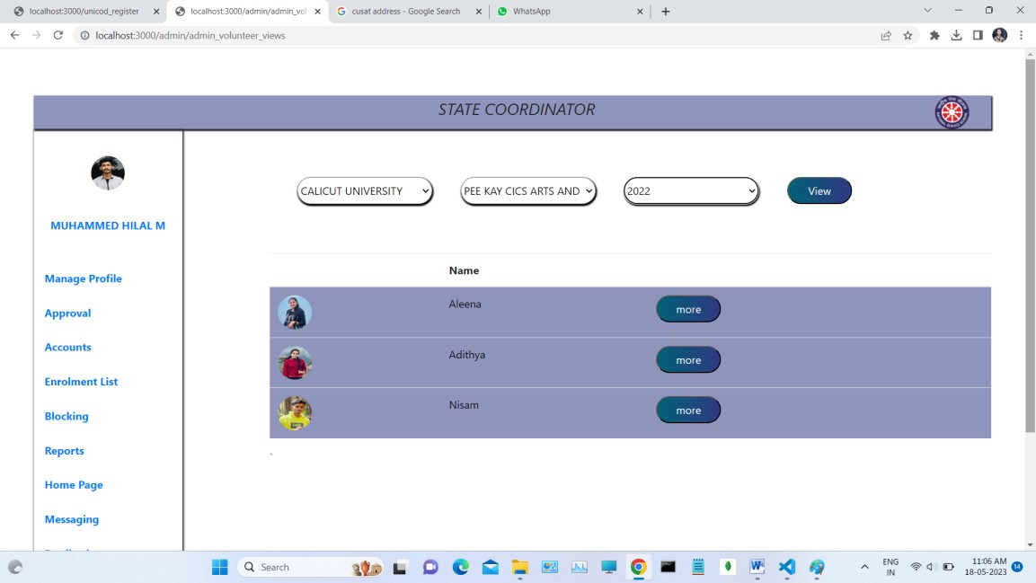

#### Block The University Coordinator

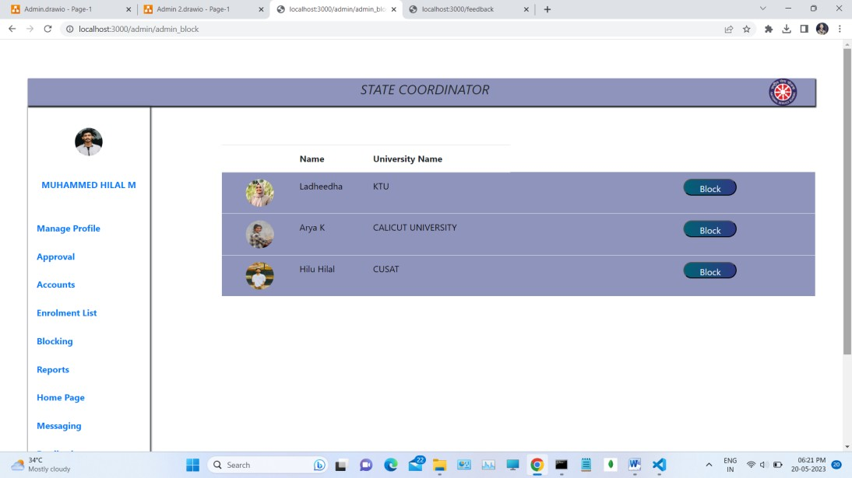

**Unblock The University Coordinator**

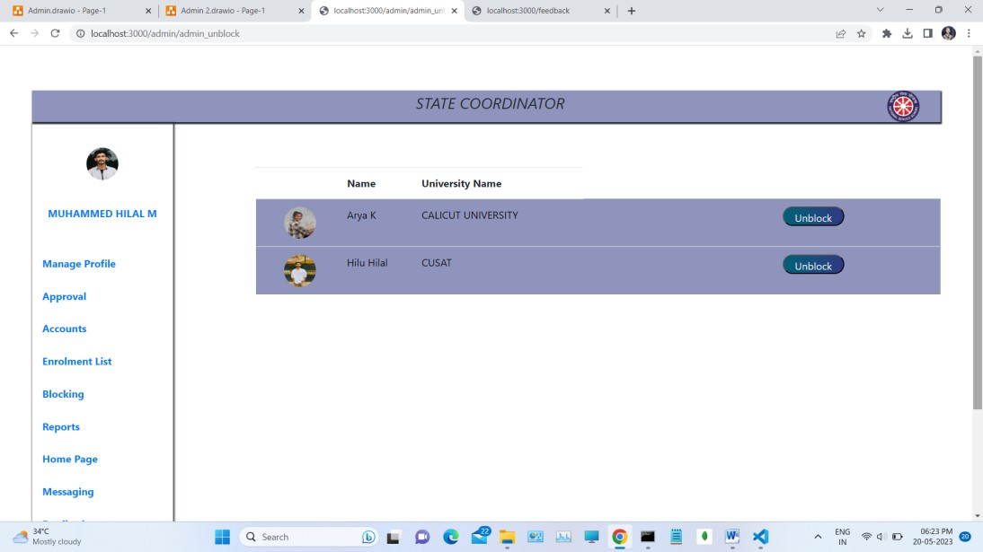

#### Project Report List View

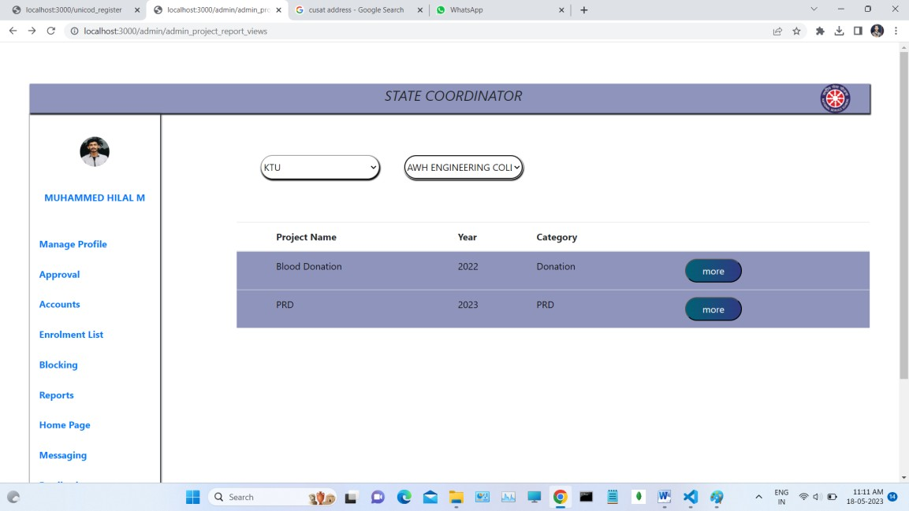

**Camp Report List View**

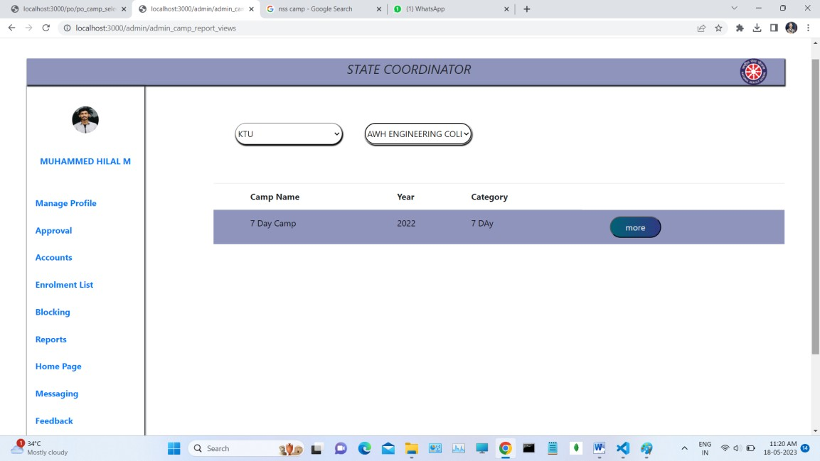

#### Add Events

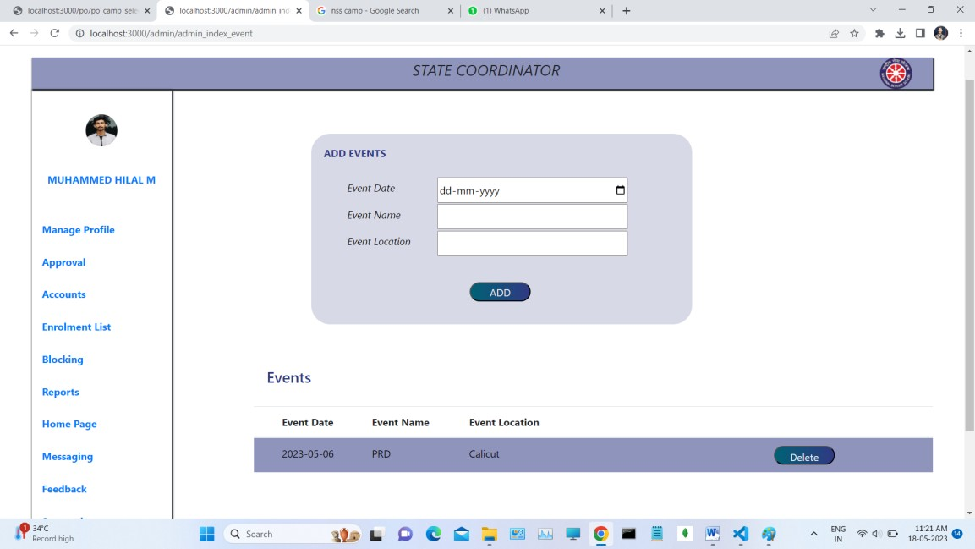

**Add News**

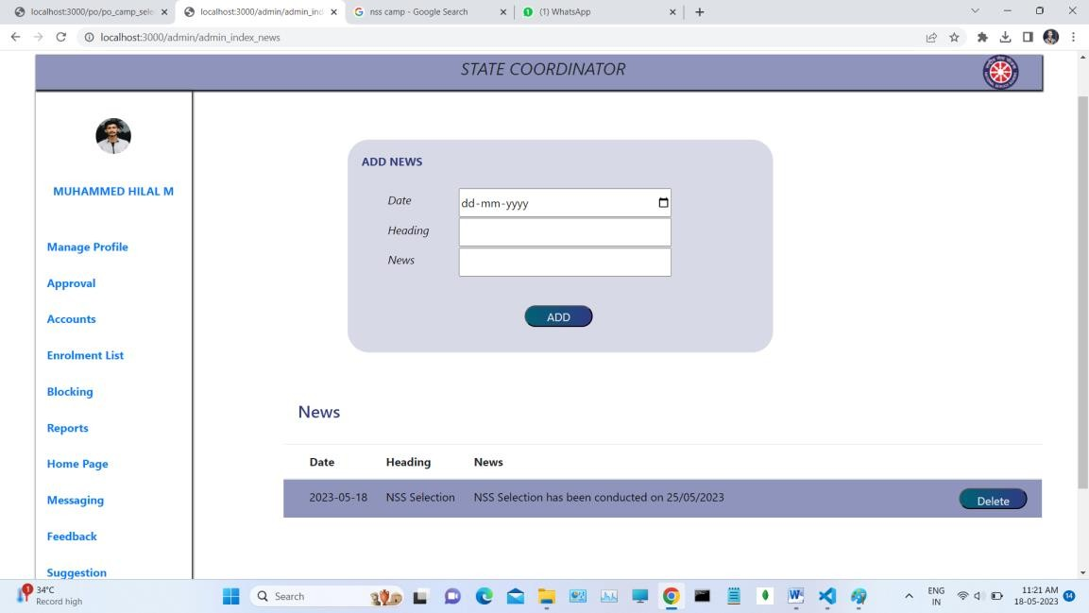

#### Messaging to University Coordinator

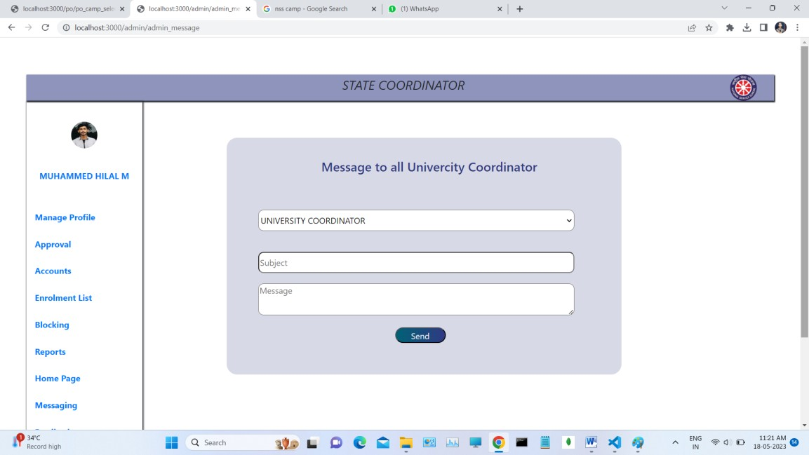

**Feedback View of State Coordinator**

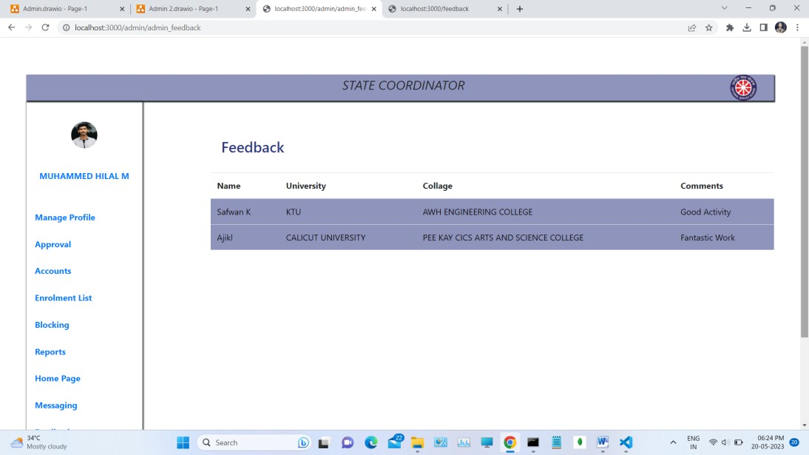

#### Suggestion View

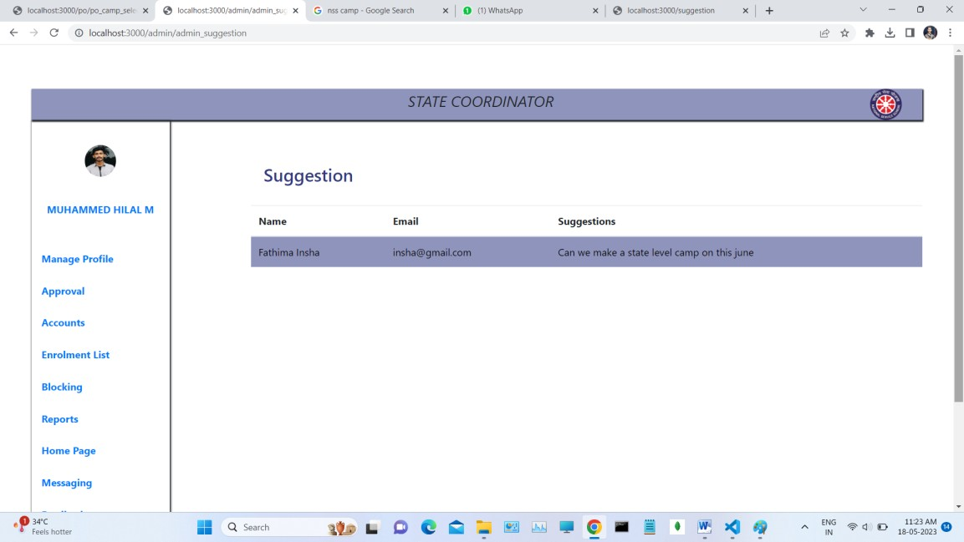

**Authentication of Program Officer**

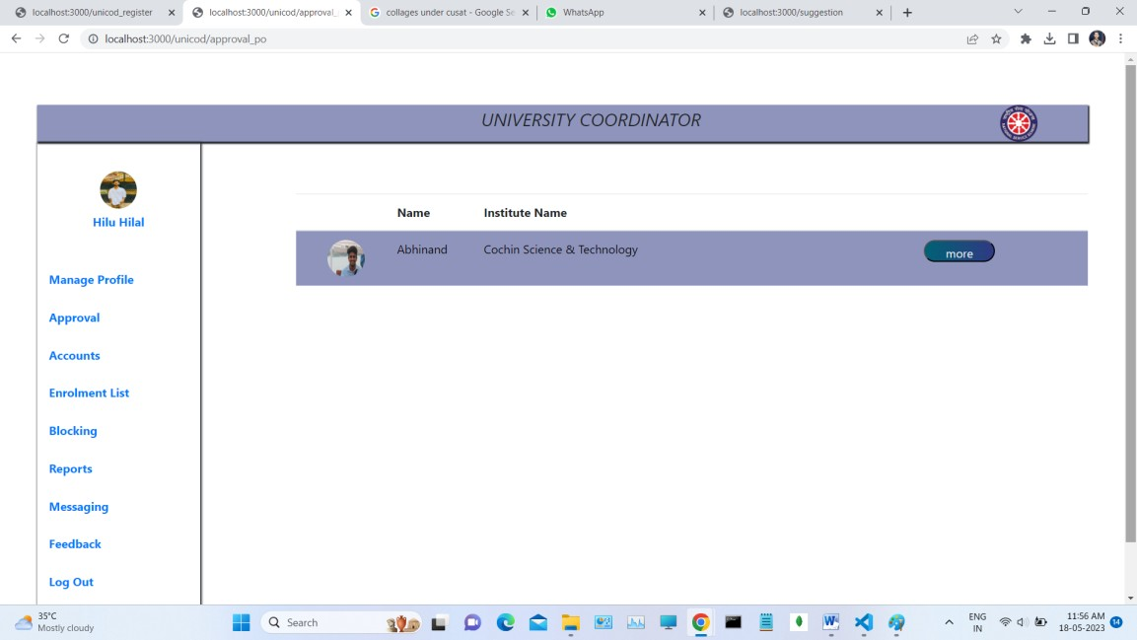

#### Add Fund Details of Institutes

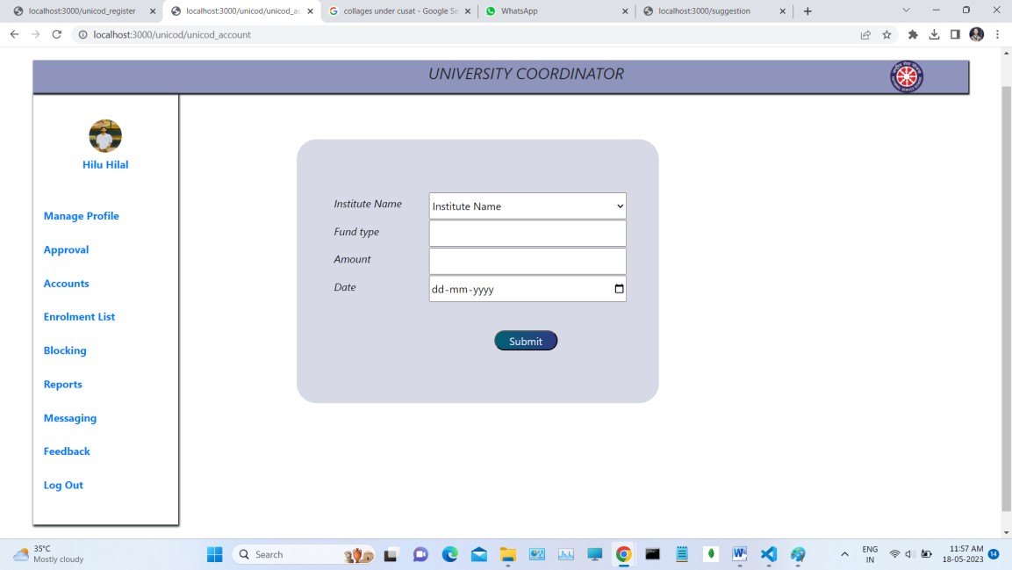

**Fund Details View of Institutes**

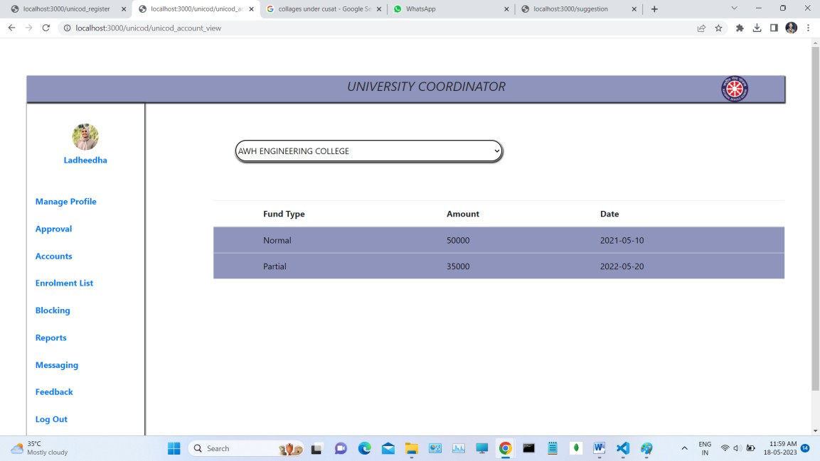

#### Block the Program Officer

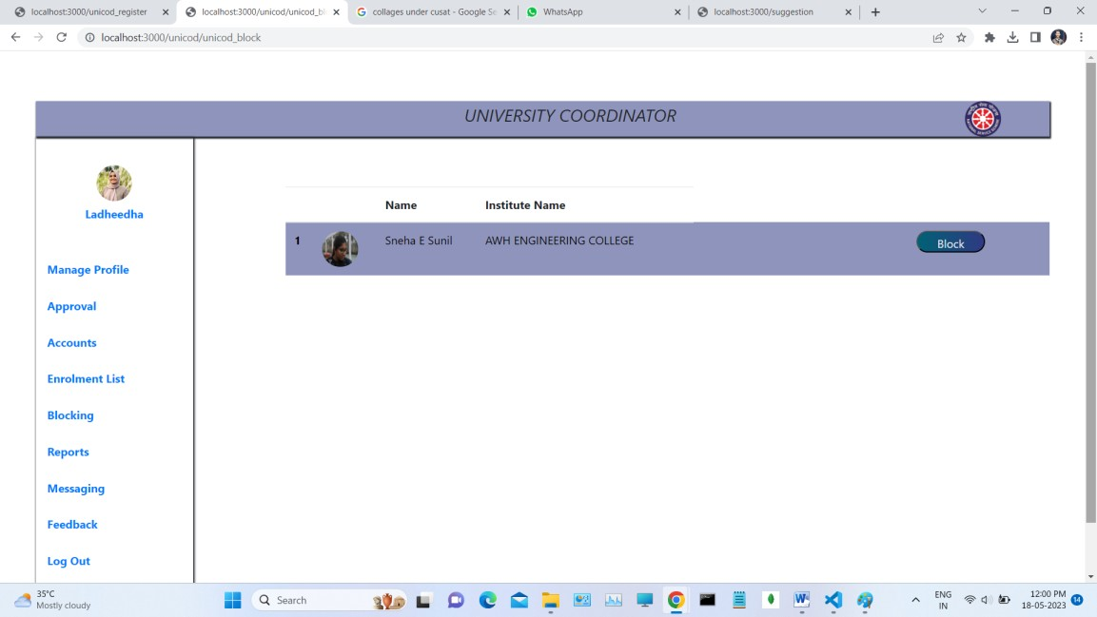

**Unblock the Program Officer**

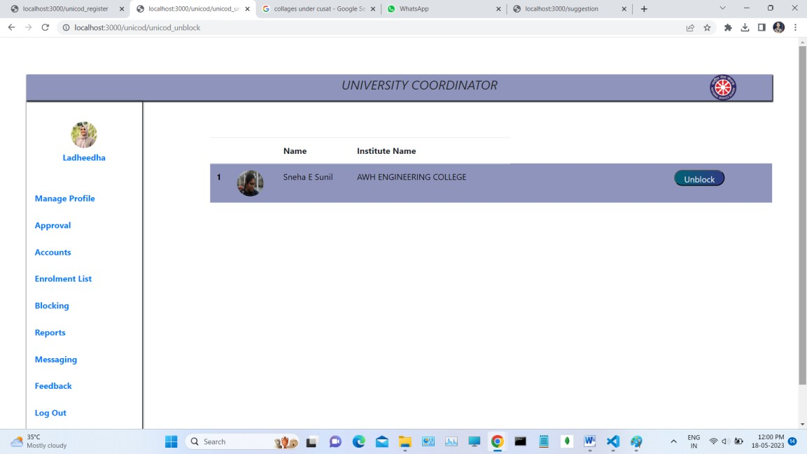

#### Messaging to Program Officer

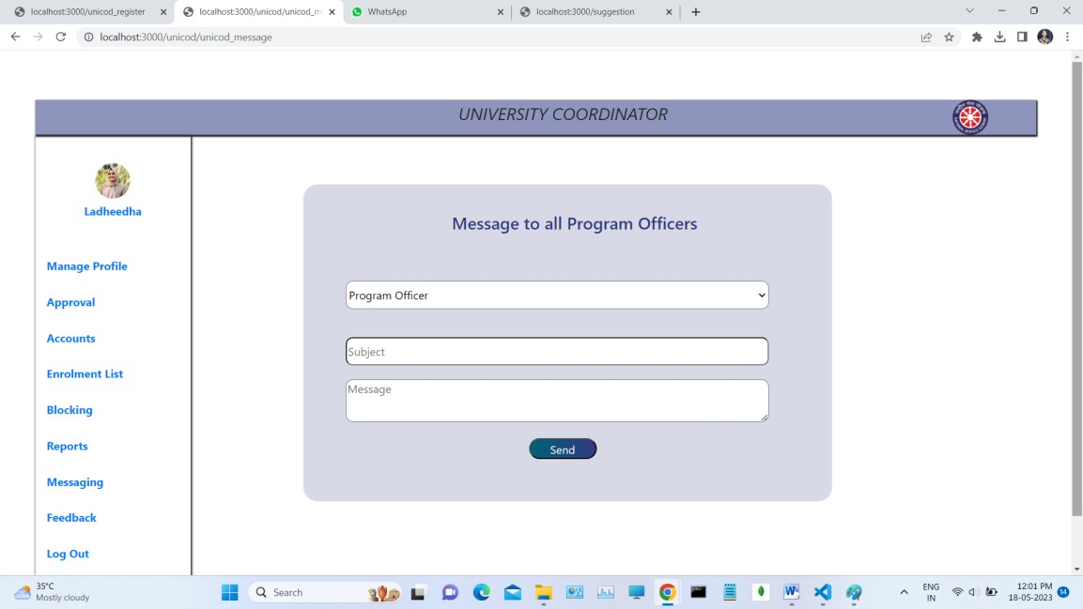

**Feedback View Of University Coordinator**

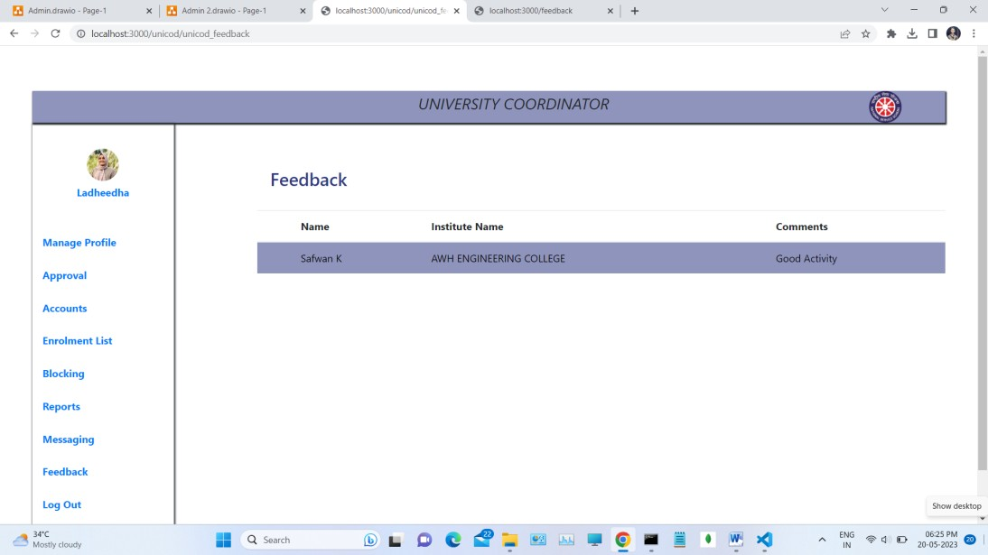

#### Authentication List of Volunteers

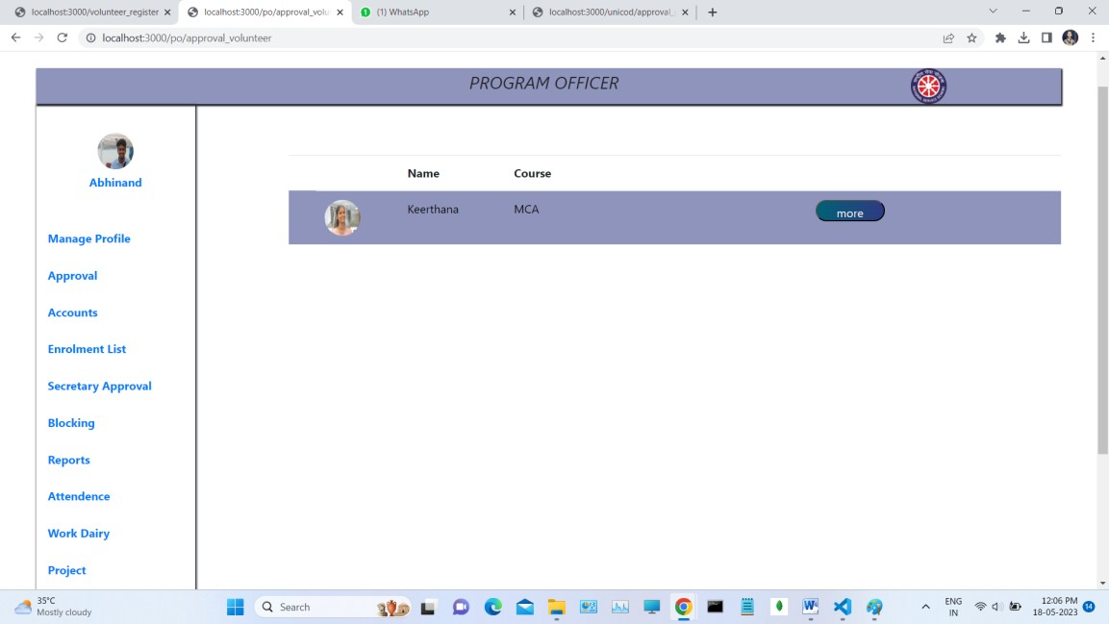

**Authentication of Volunteers**

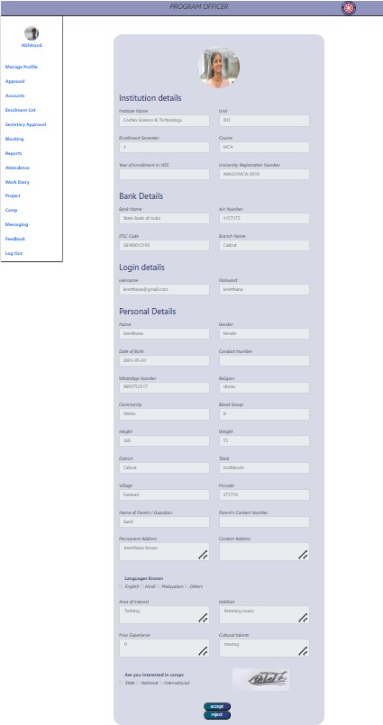



#### Add Expenses of Institute

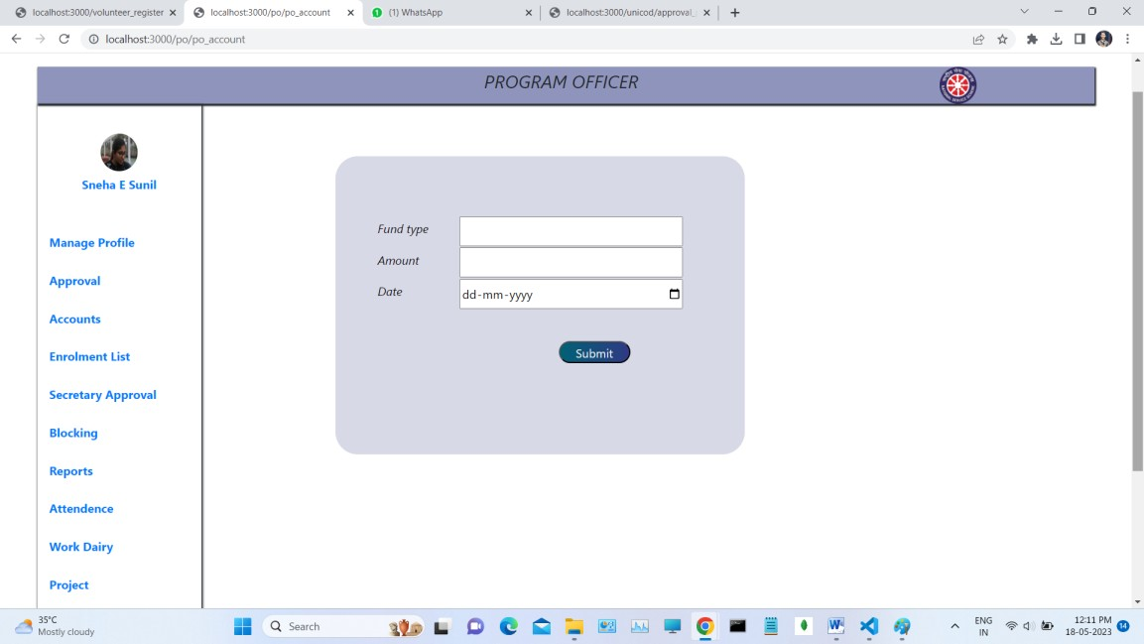

**Expense View of Institute**

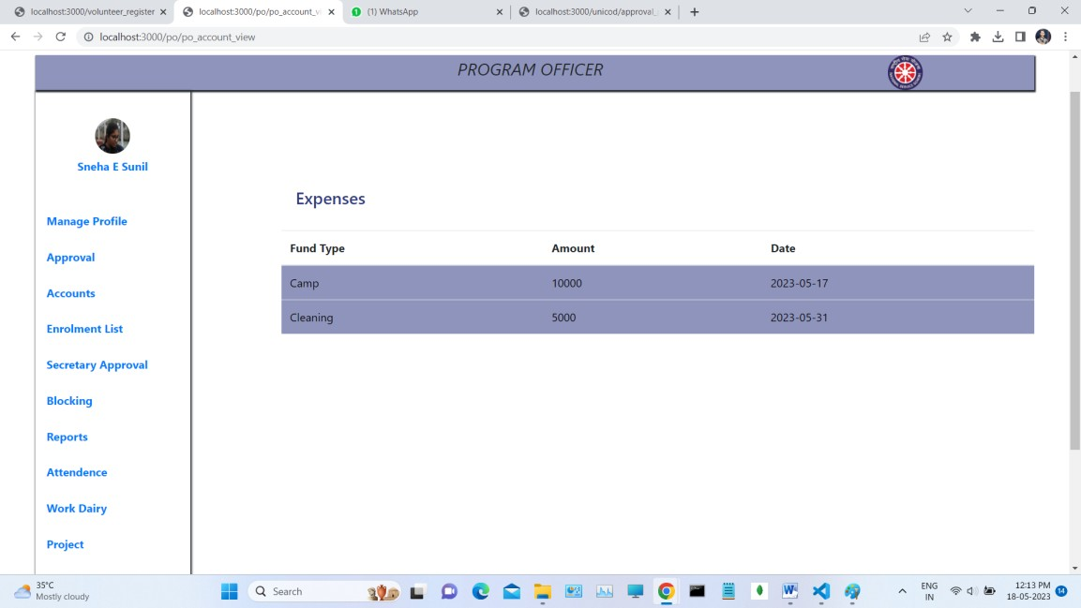

#### Secretary Approval

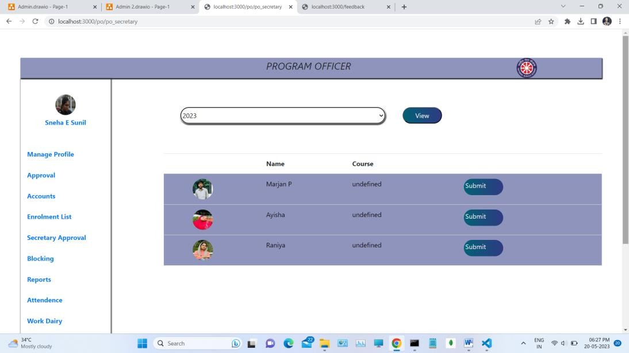

**Approved Secretary View**

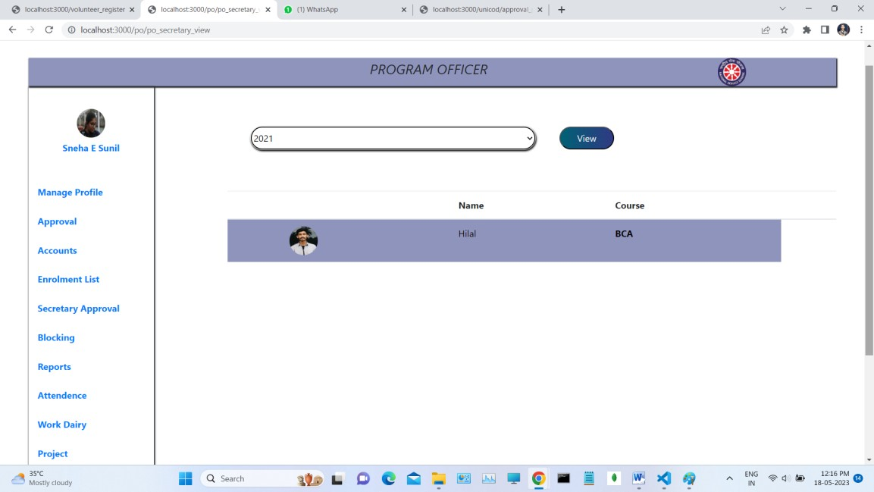

#### Block the Volunteers

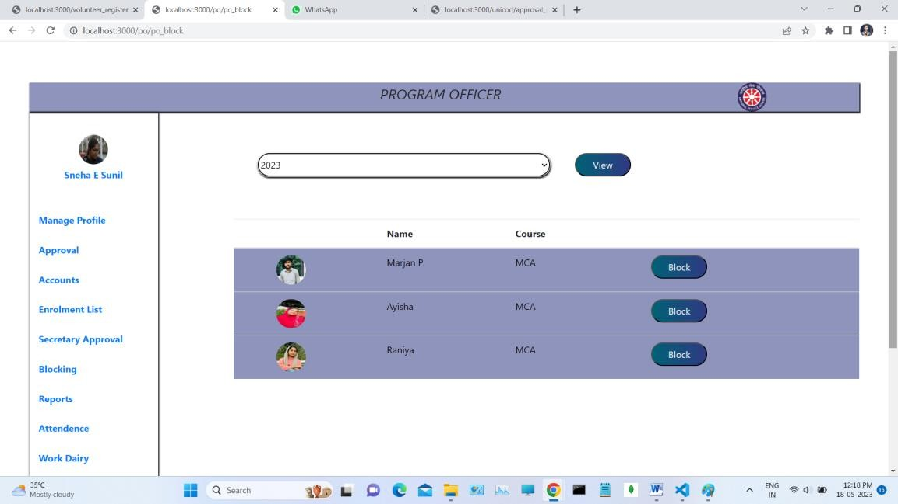

**Unblock the Volunteers**

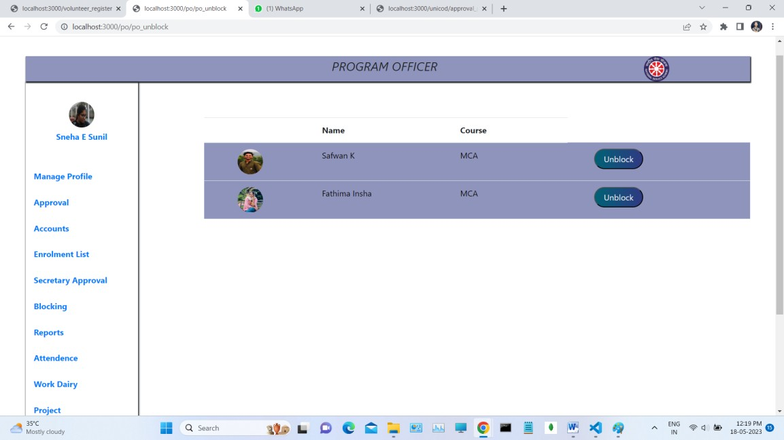

#### Project Creation

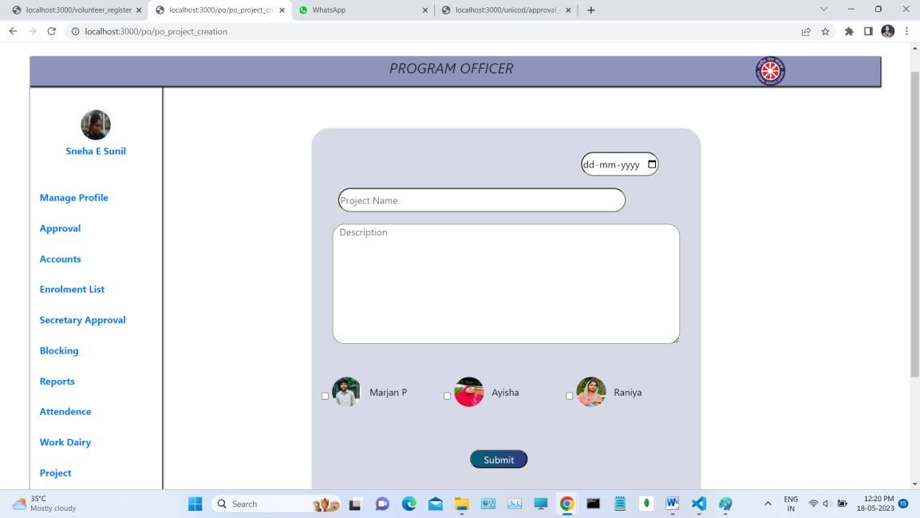

**Add Project Report**

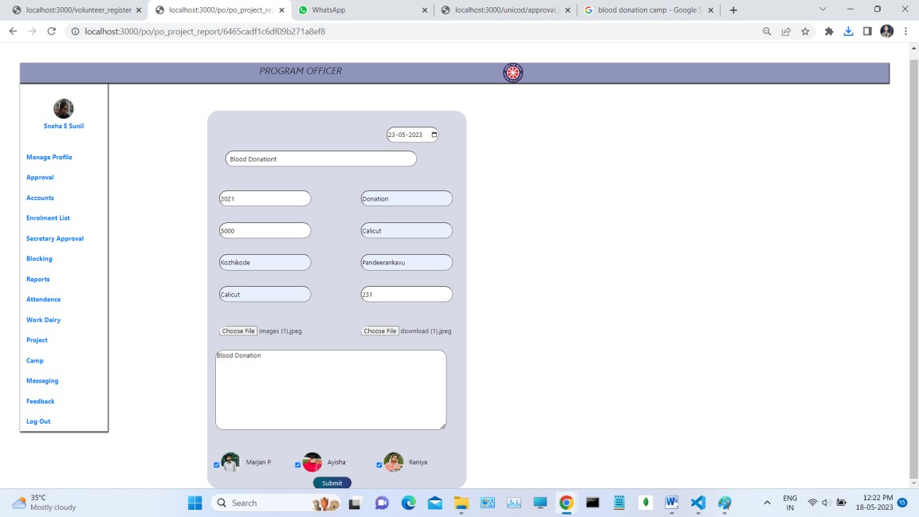

#### Project Report View

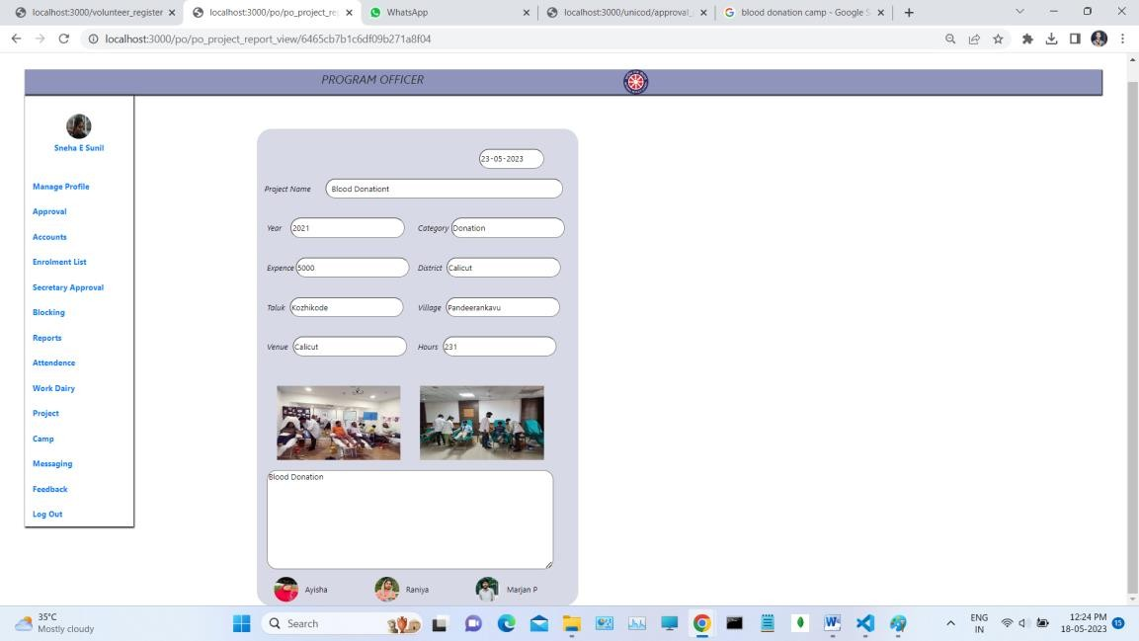

**Camp Creation**

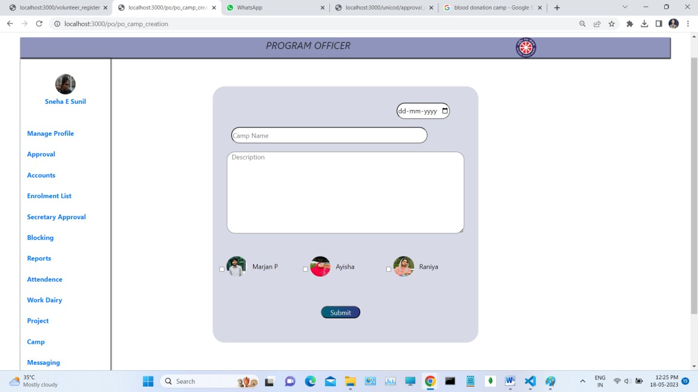

#### Add Camp Report

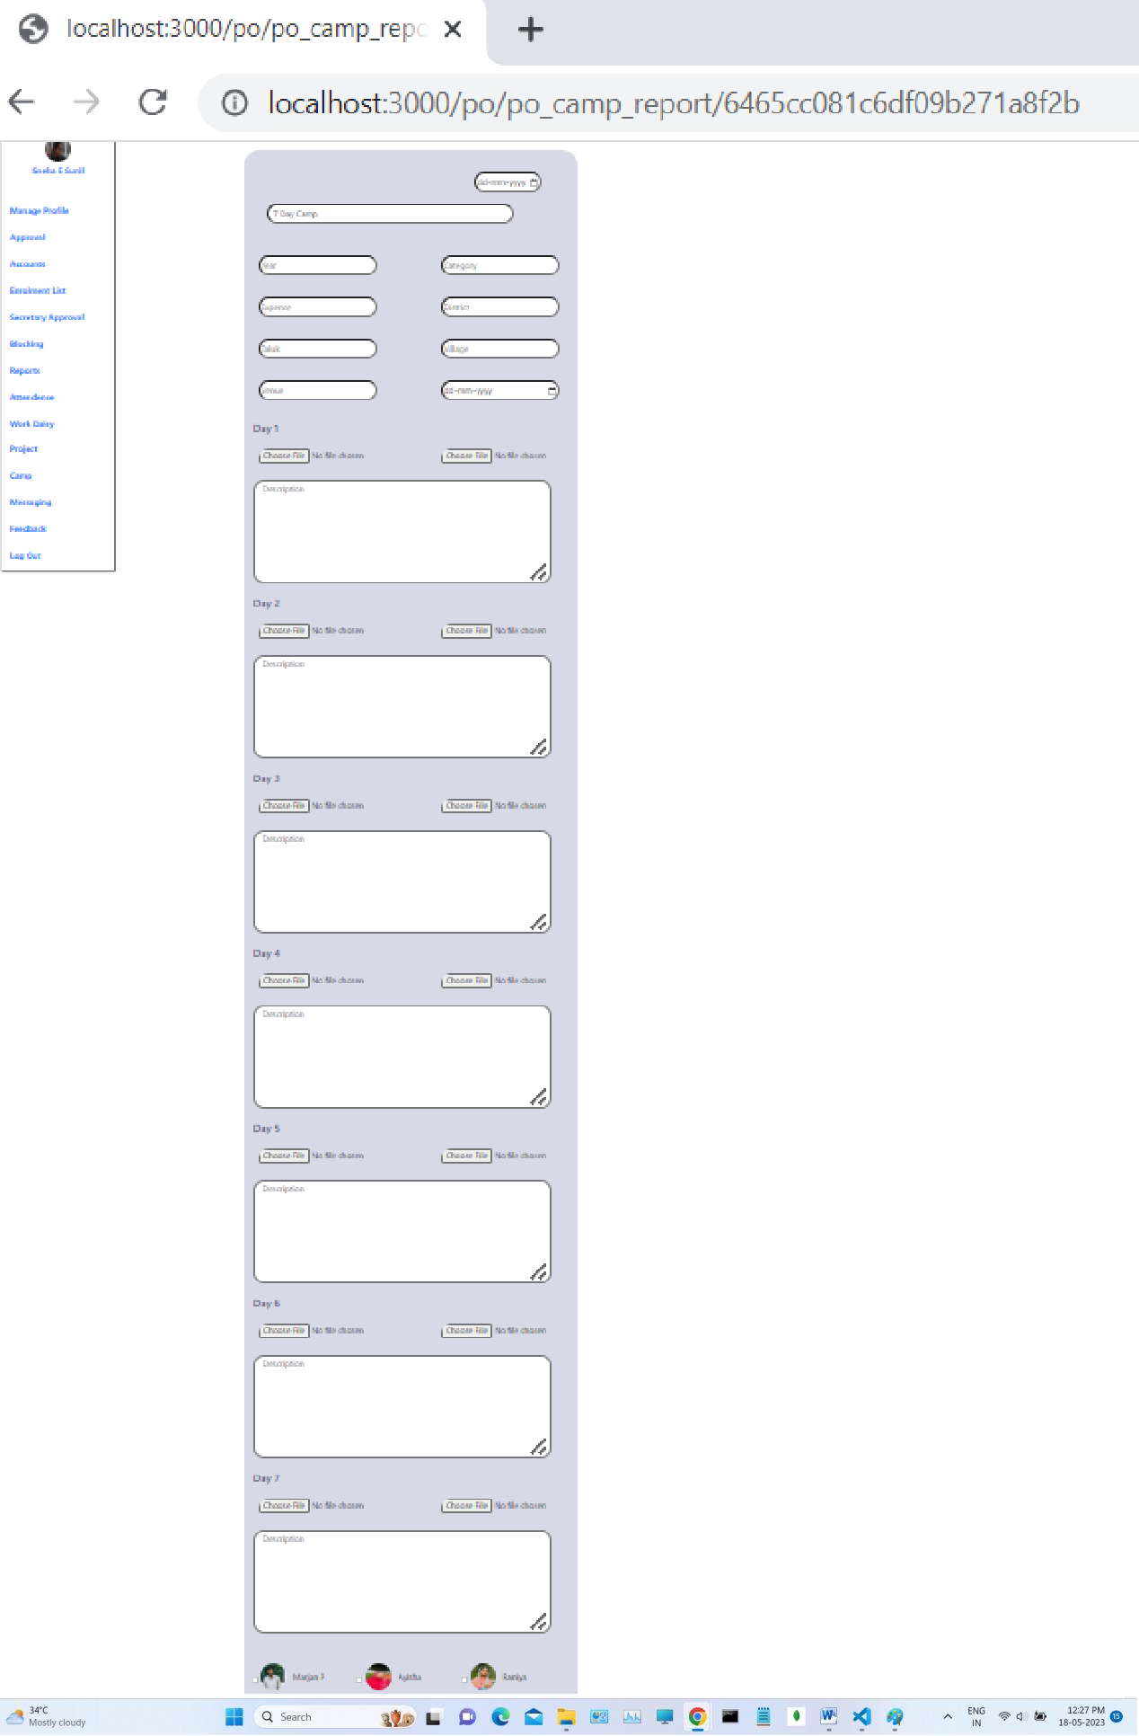

**Camp Report View**

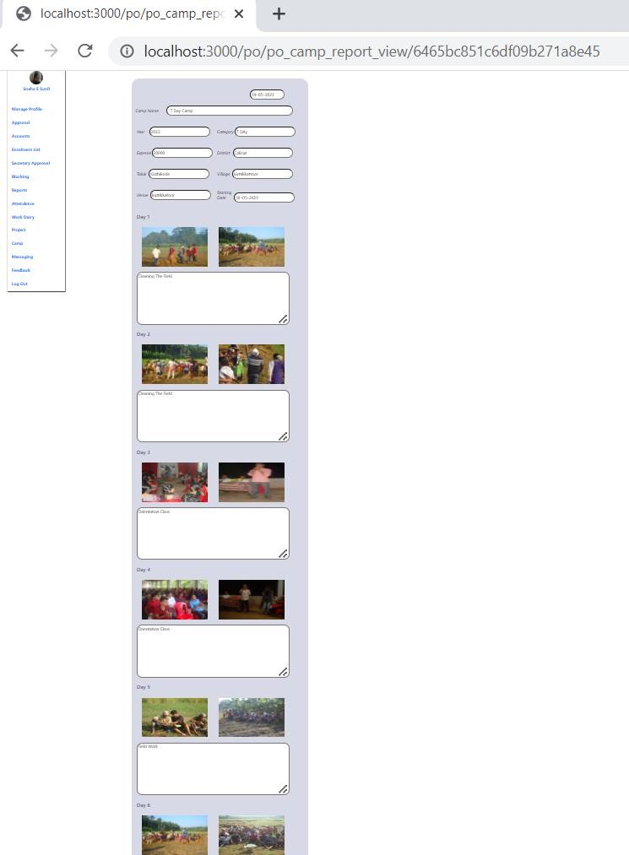

#### Attendance View

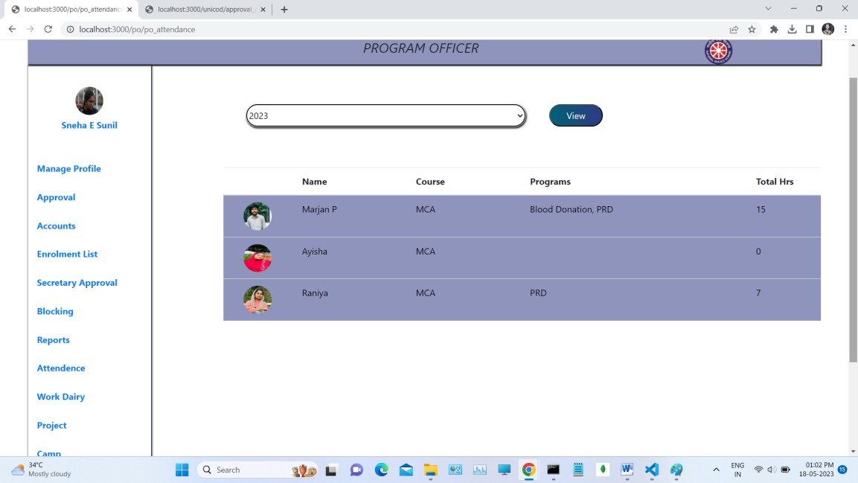

**Add Work Dairy Of Program Officer**

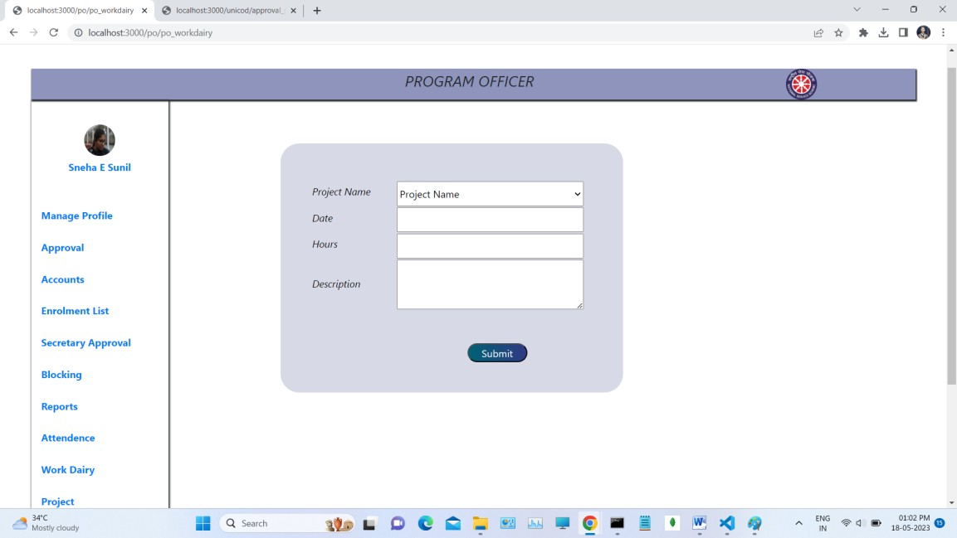

#### Work Dairy View of Program Officer

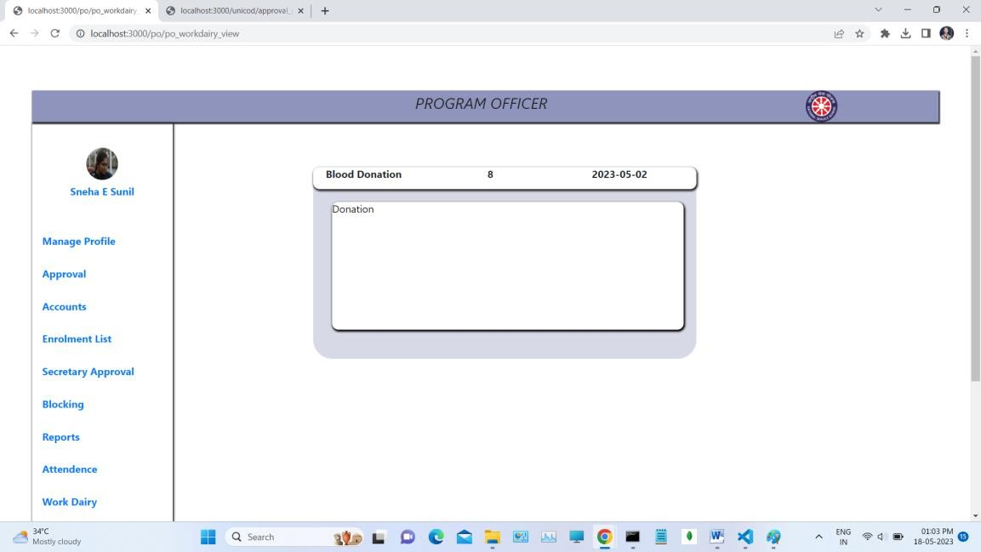

**Messaging to Volunteers**

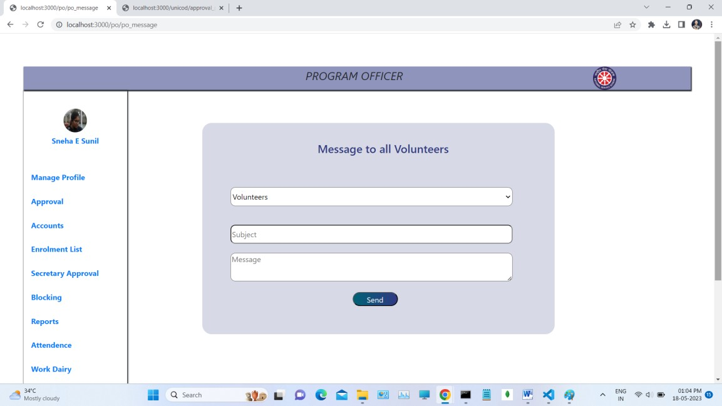

#### Feedback View of Program Officer

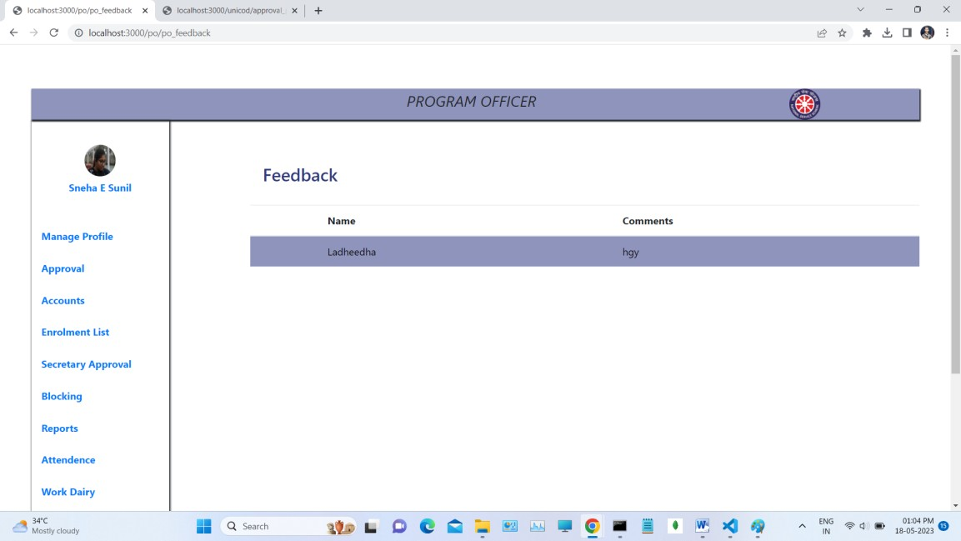

**Secretary Add Project Report**

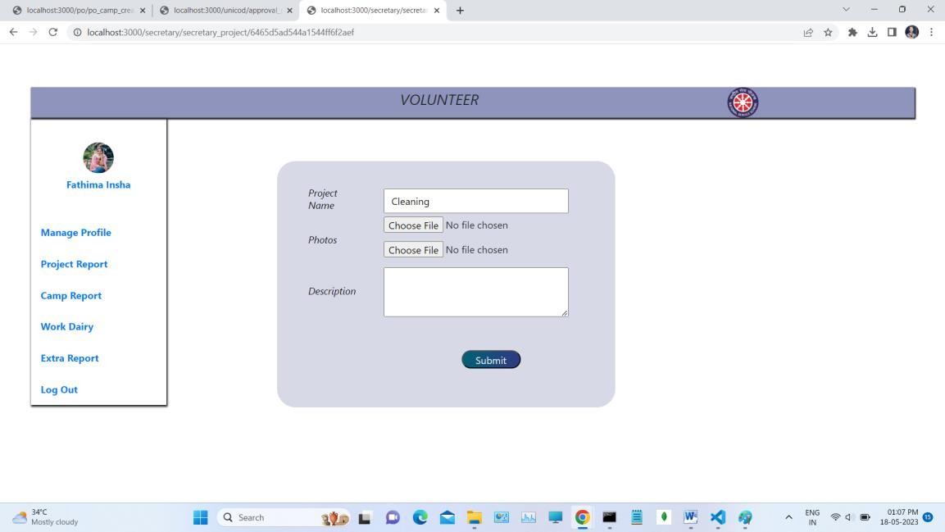

#### Secretary Add Camp Report

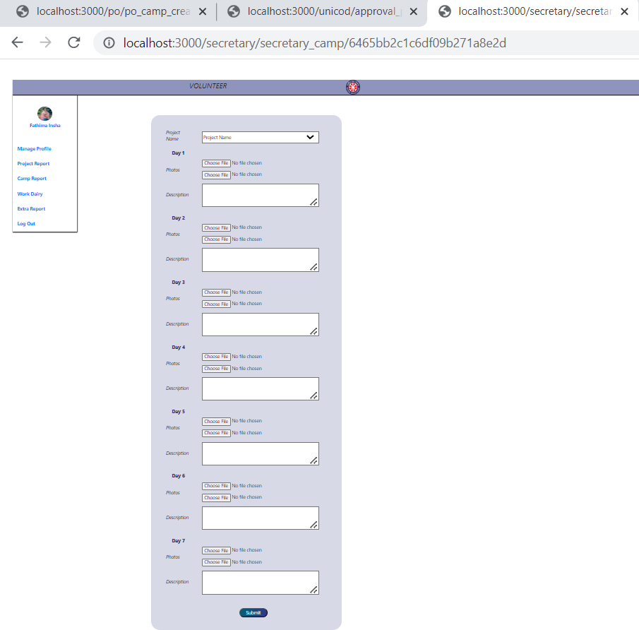



**Add Work Dairy of Volunteers**

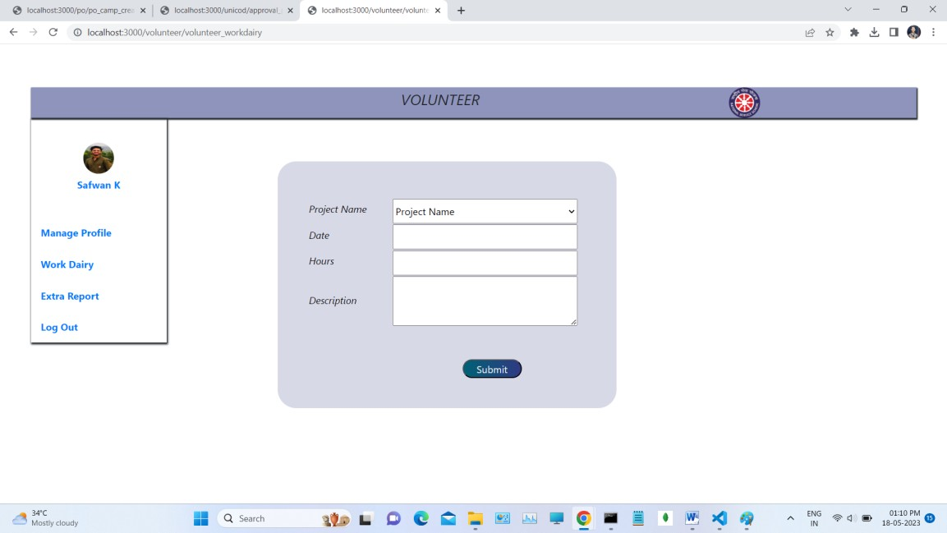

#### Work Dairy View of Volunteers

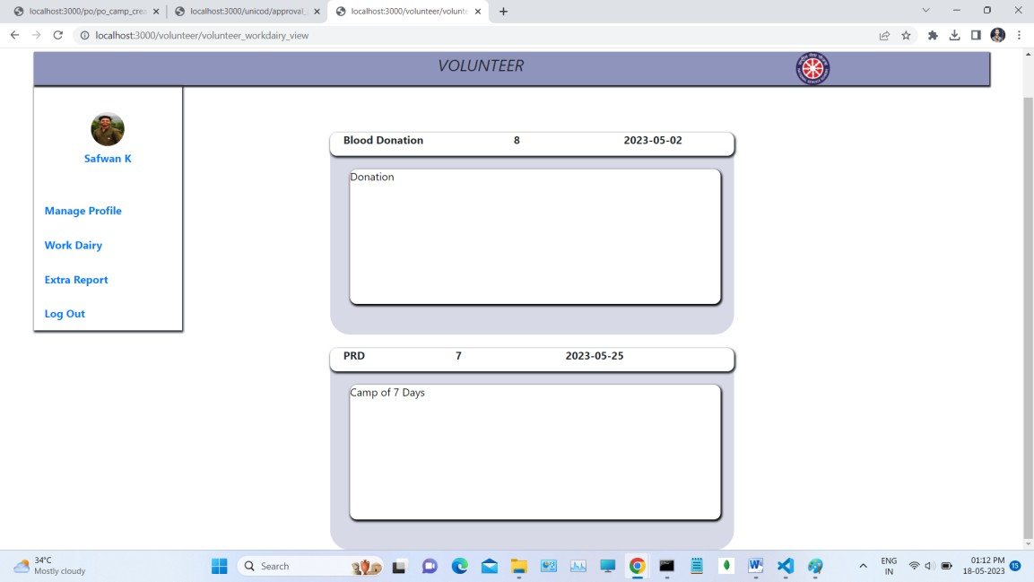

**Add Extra Work Report**

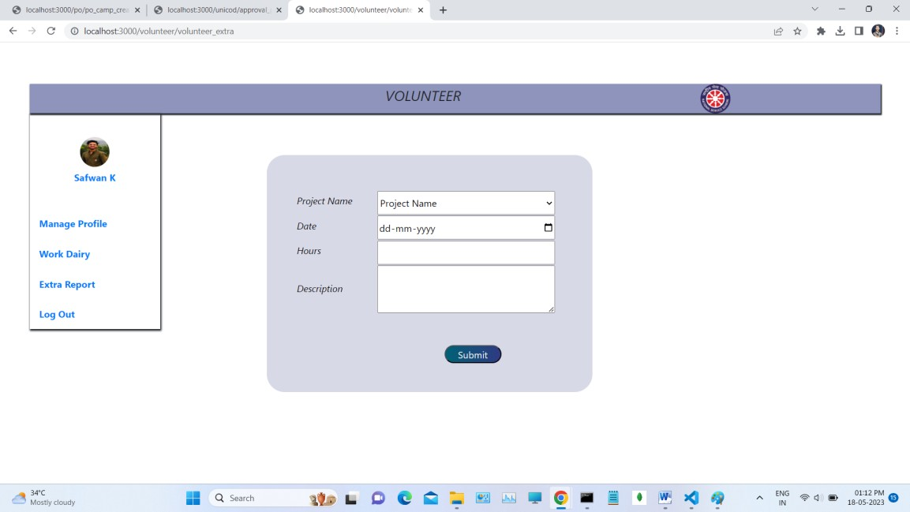

**View Extra Work Reports**

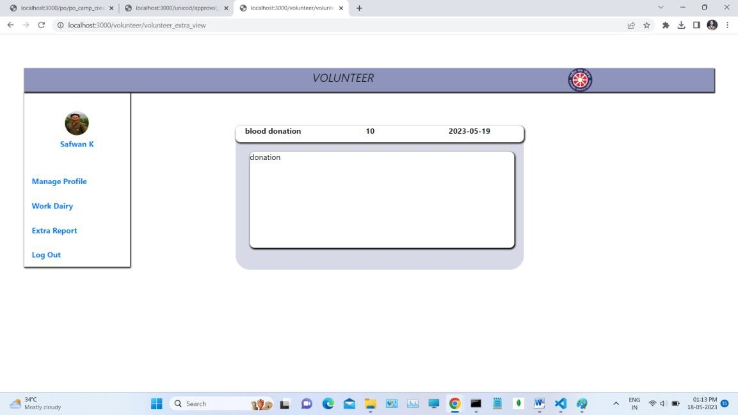

# BIBILOGRAPHY

## BIBLIOGRAPHY

Websites

1. *htt*[*ps://w*](http://www.mongodb.com/docs)*ww*[*.mongodb.com/doc*](http://www.mongodb.com/docs)*s*
2. https://expressjs.com/
3. *https://nodejs.org/en/docs*
4. *https://bootstrapmade.com*/*onepage-multipurpsode-bootstrap-template*
5. *https://developer.mozilla.org/en-US/docs/Web/HTML*
6. *https://developer.mozilla.org/en-US/docs/Web/CSS*

**Books**

1. *Thomas A Powell, Fritz Schneider, “JavaScript: The Complete Reference”, 3rd Edition, Tata McGraw Hill*
2. *Pro MERN Stack: Full Stack Web App Development with Mongo,*

*Express, React, and Node" by Vasan Subramanian*

1. *Code complete: a practical handbook of software construction by Steve McConnell, Microsoft Press,2nd Edition(2004).*
2. *Full Stack Development with JHipster: Build scalable and maintainable web applications using the MERN stack" by Deepu K Sasidharan and Sendil Kumar N*
3. *Full Stack JavaScript: Learn Backbone.js, Node.js, and MongoDB" by Azat Mardan*